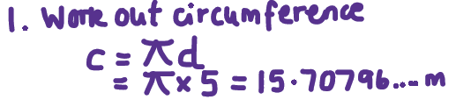  Question  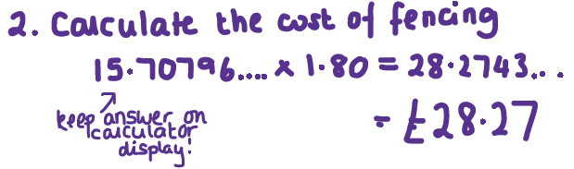  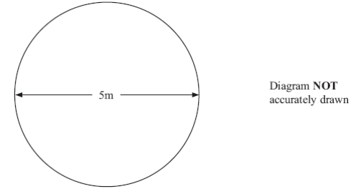  Jon has a flower garden in the shape of a circle.  The diameter of the garden is 5 metres.  Jon wants to put fencing around the edge of the garden.    The fencing costs £1.80 per metre.  Work out the total cost of the fencing. | CIRCLES CIRCUMFERENCE  AND AREA  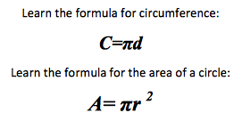 | Exam Practice  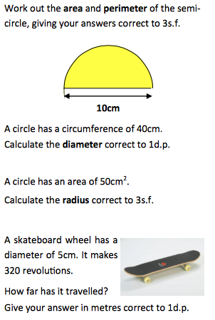
Skills Practice
