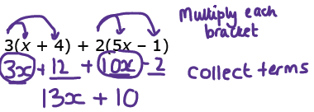  Question  (a)  Expand and simplify 3(x + 4) + 2(5x – 1)  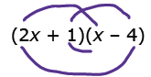  Expand and simplify (2x + 1)(x – 4)  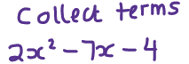  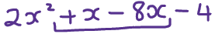  Factorise completely 6y² – 9xy  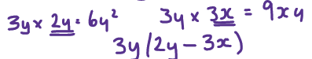   | EXPANDING AND FACTORISING  Single bracket  Multiply the term outside the bracket by everything inside the bracket.  Double brackets  Remember you get 4 terms in your first answer. Simplify the x’s to leave you with 3 terms.  Factorising  Find the highest common numerical factor and any letters in common to take outside the brackets. | Exam Practice  1. (a) Expand 3(x + 2)  (b) Factorise fully 6ab + 10ac  (c) Expand and simplify  (x − 5)(x + 7)  2. (a) Expand and simplify  3 + 2( p – 1)  (b) Expand and simplify  5(x + 7) + 3(x – 2)  (c) Factorise completely  12 x³y – 18 xy²  (d) Expand and simplify  (2x – 3)(x + 4)  3. Factorise ax + bx + ay + by
Skills Practice

Expand and simplify:
a) 3(x + 5) – 9 b) 4(5x – 2) + 11x – 5 c) -3(7 + 5y) + 9y – 10 d) -8(5x – 6) + 24

Expand and simplify:
a) (x + 7)(x + 4) b) (x + 2)(x + 6) c)(x - 3)(x + 8) d)(x + 10)(x - 3) e) (x + 5)²

Factorise:
a) 4x + 6 b) 6y + 15 c) 7m – 84 d) x² + 6x e) 5x³ + 10x²

