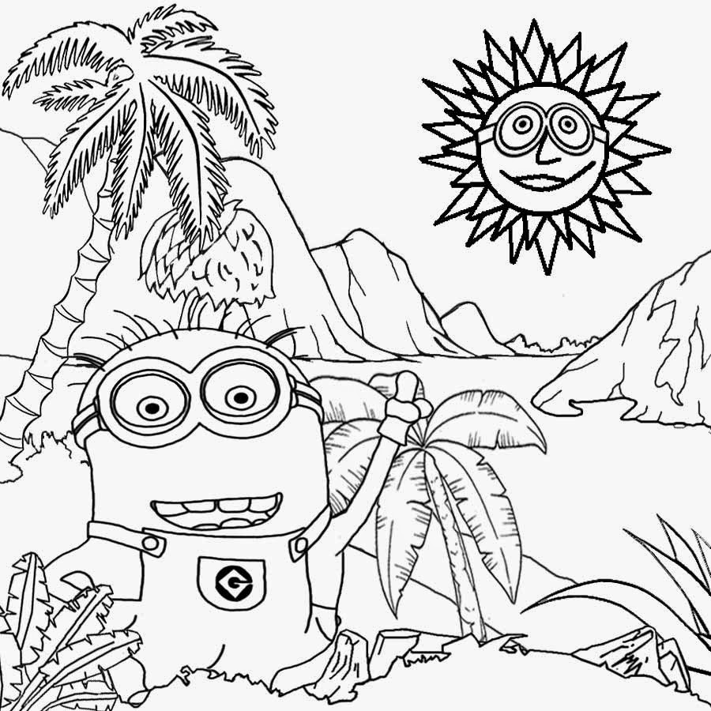

Complete the division calculations in the table below. You must show your workings.
Find the correct picture answer and place in that position.
When all calculations have been completed correctly, the picture will be arranged correctly.

45.6 ÷ 6 | 63.2 ÷ 8 | 39.2 ÷ 7
149.6 ÷ 11 | 52.4 ÷ 4 | 64.8 ÷ 12
74 ÷ 5 | 93 ÷ 15 | 365 ÷ 25

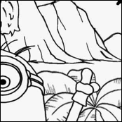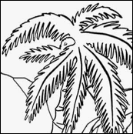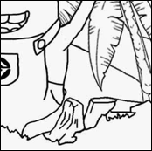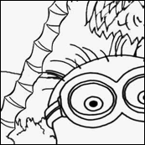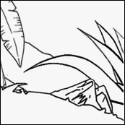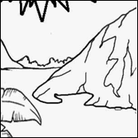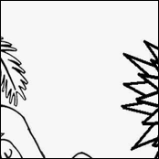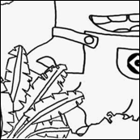
14.8
7.9
5.4
5.6
13.6
14.6
6.2
7.6
13.1

