L.Q. How do I use conversion graphs to solve problems? | Date:
L.Q. How do I use conversion graphs to solve problems? | Name:

Conversion means….

1. This is a conversion graph between pounds and kilograms.
(a) Use the graph to make an approximate conversion of:
- 10kg to pounds ______
- 18lb to kilograms _______
- 40lb to kilograms
________
- 25kg to pounds

________
(b) Approximately how many pounds are equivalent to 1kg?

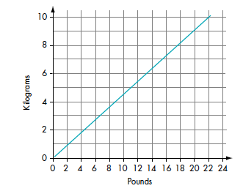

2. This graph shows the approximate equivalence of the British pound (£) to the Singapore dollar ($).
(a) Use the graph to make an approximate conversion of:
- £50 to dollars ______
- $150 to pounds ______
- £120 to dollars
________
- $500 to pounds

________
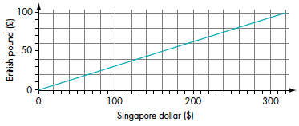

3. This graph shows the conversion between miles and kilometres.
(a) Use the graph to make an approximate conversion of:

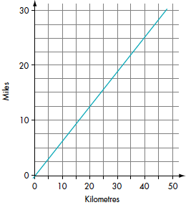
- 25 miles to km ______
- 40km to miles ______
- 120km to miles
______
- 70 miles to km
______

(b) Approximately how many kilometres are equivalent to 5 miles?
When problem solving with conversion graphs…

Ella has $400 and £400. Her hotel bill is $1200.
Ella pays the bill with the $400 and some of the pounds.
Use the conversion graph to work out how many pounds she has left.

This conversion graph can be used to change between metres and feet.  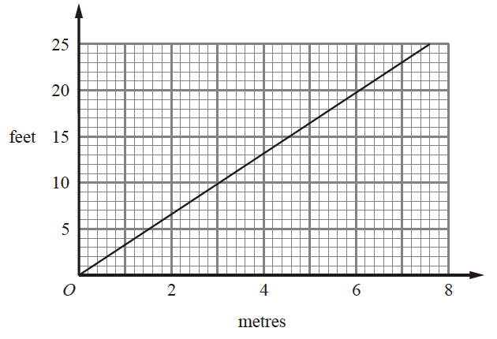  - Use the conversion graph to change 8 feet to metres. |  | - Jack buys 18 feet of edging for £35.  Francoise buys 2m of edging for £12.  Who gets the better value for their money, Jack or Francoise? You must show your working.
The exchange rate to change pounds (£) into US dollars ($) is £1 = $1.50.  (a) Use this exchange rate to complete the table below:  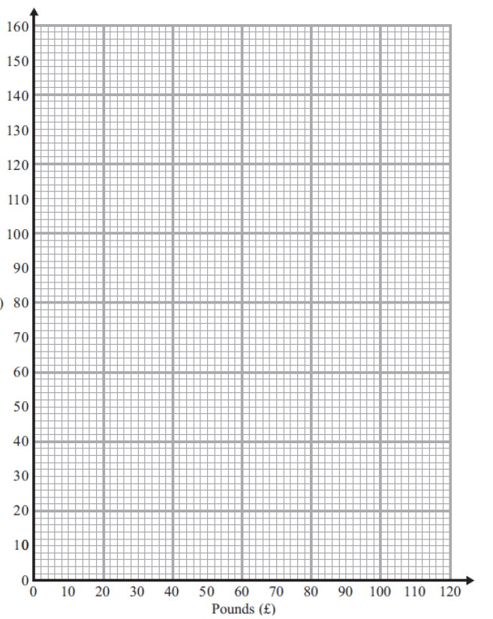  (c) Use your graph to change $100 into pounds (£). | You can use this conversion graph to change between miles and kilometres.  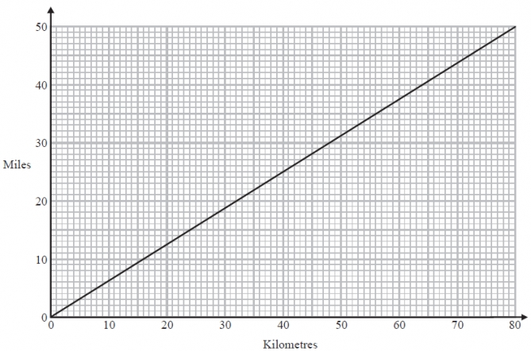  Mary has to drive from Birmingham to Inverness. The total distance is 450 miles.  Mary has already driven 320km to the Scottish borders. Mary has enough petrol to drive up to 220miles. Does she need to stop for petrol on her way to Inverness?
  £ | 0 | 1 | 2 | 5 | 10 | 20 | 50 | 100
  $ | 0 | 1.50

