L.Q. Can I interpret and accurately draw charts displaying data? | Date:
 | Name:

A BAR CHART displays DISCRETE data, data which can only take exact values. It must have:
- Labelled axes
- Gaps between the bars
- A correct scale on the axes
- Bars the same width and accurately drawn
- A key for compound or composite bar charts

- The bar chart gives information about the numbers of students in the four year 11 classes at Trowton School.
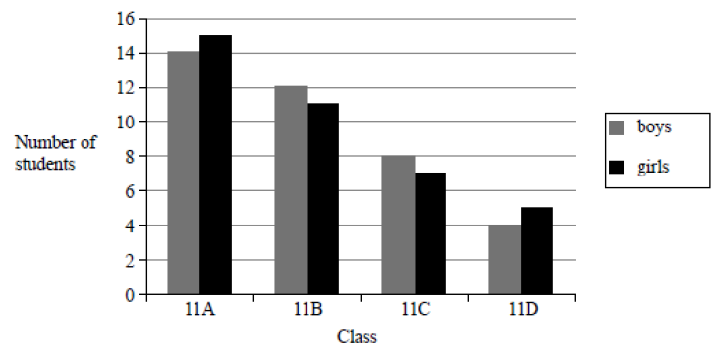
Girls in 11A
All pupils in 11A
- What fraction of the students in class 11A are girls?
- Shola says “there are more boys than girls in Trowton School”.
Is Shola correct? You must give a reason for your answer.

- This chart shows a firm’s profit in each of the three years:
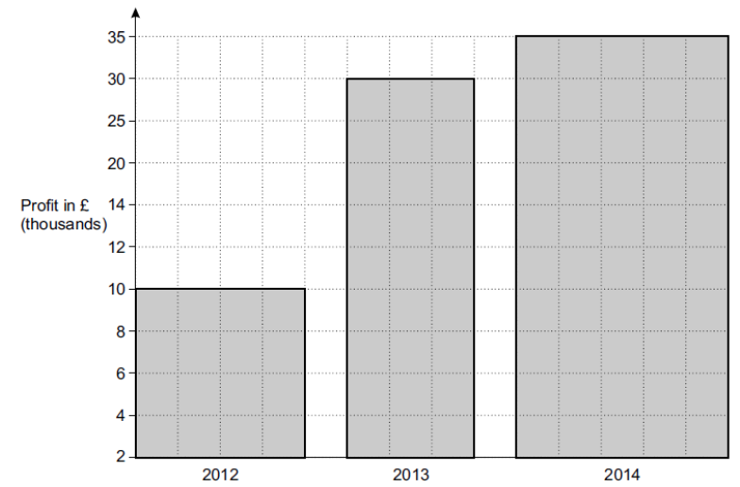
Give two reasons why it is misleading.

- Some people were asked if they liked swimming or cycling or running.
The table shows the results for the males and the results for the females.
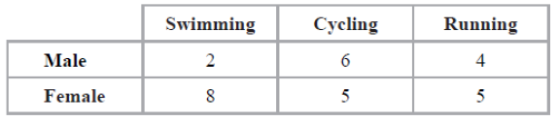
Check the list at the beginning to ensure you have included everything.
On the grid, draw a bar chart to show this information.

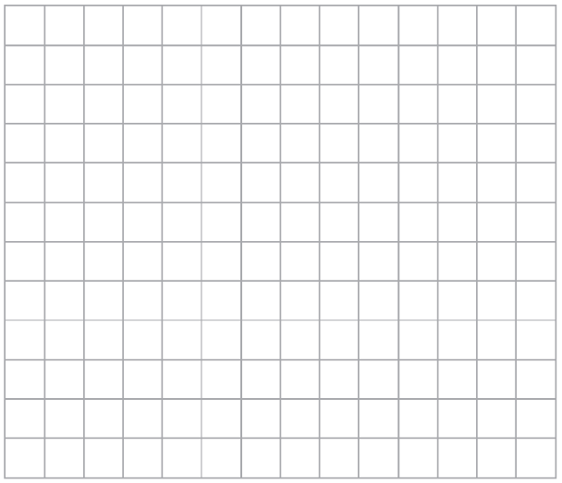

A PE CHART shows the PROPORTION or FRACTION of each category compared to the whole circle.
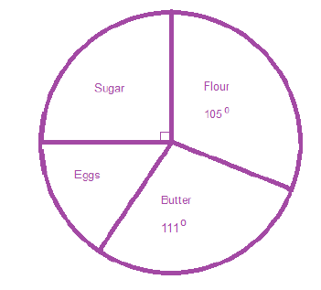
- The pie chart shows the ingredients needed to make a 720g cake.

- Which ingredient is used the most?

- What fraction of the cake is sugar?
Work out the angle for the eggs first.
Make this a fraction out of the total angles in a circle.
- What fraction of the cake is eggs?
Write the amount of flour as a fraction of the whole pie chart, then multiply by the total cake.
- How much flour is needed to make the cake?
- The table gives information about a group of peoples’ favourite pizza.
Angles must add to 360º in a pie chart.
What do you multiply the total by to get 360º?
Pizza | Frequency | Working | Angle
Meat Feast | 10 | x_____ =
Veggie | 23 | x_____ =
Spicy Chicken | 39 | x_____ =
Total |  | x_____ = | 360

Multiply all the frequencies by the same value to give you the angles.
Draw an accurate pie chart to show this information
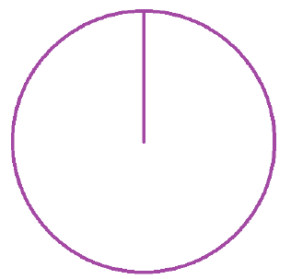

- Some research was done into the popularity of different coloured cars.
The results are to be used to draw a pie chart.
Some of the results are shown in the table.
Remember you multiply all the frequencies by the same value to give you the angle.
Colour | Frequency | Angle
Blue | 22
White | 16
Black | 10 | 50º
Red |  | 30º
Other |  | 90º
a) Complete the table.
b) Write down the most popular colour.
c) Draw a pie chart to show this information.

