5 8 11 14 17 | 4 12 36 108 324 | 3 7 12 18 25

For each sequence below, write the rule and the missing term:

Rule: Missing term: Rule: Missing term:

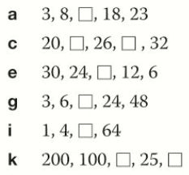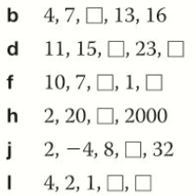

Challenge: A sequence of numbers is generated by this rule:
Start with 5, multiply by 2 and add 3 to generate the next term.
- Find the first 5 terms.
- The term 1021 is in the sequence. Calculate the term that is immediately before 1021.

Using the nth term | $$T\left(n\right)=3n+3$$  First 5 terms:  15th term:  99 is in the sequence.  What term is it?

Nth term | 1st term | 2nd term | 3rd term | 4th term | 5th term
$$3n$$ |  |  |  |  |  | 12th term
$$2n+4$$ |  |  |  |  |  | 20th term
$$4n-9$$ |  |  |  |  |  | 15th term
$$2-4n$$ |  |  |  |  |  | 8th term
$$n^{2}$$ |  |  |  |  |  | 11th term
$${2n}^{2}$$ |  |  |  |  |  | 10th term
$$n^{2}+6$$ |  |  |  |  |  | 9th term
$${2n}^{2}-3n$$ |  |  |  |  |  | 8th term

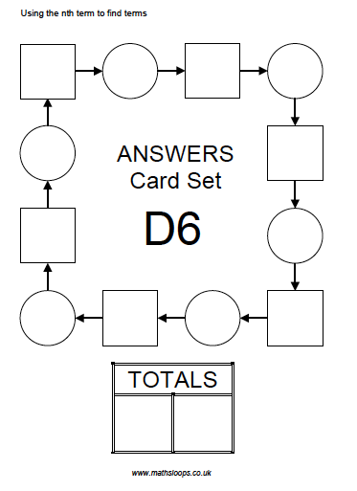

- Here are the first 5 terms of an arithmetic sequence
5, 9, 13, 17, 21, ,
- Write down the next 2 terms
- Is 206 in this sequence? You must give a reason for your answer

- A sequence has nth term $3n-2.$
- What is the 20th term?
- 145 a term in this sequence? Which term is it?

- A sequence has nth term $5n+2$.
- What is the 35th term?
- Is 363 a term in this sequence? You must show your working out.

- John has opened a new shop. In the first week John has 3 customers, in the second week John has 6 customers. John states that the number of customers is doubling from week to week
- Write down a sequence which shows how many customers John would have in the first 4 weeks if his statement is correct.
- How many customers should John expect to have after 6 weeks of being open?
- Is it realistic for John to expect the number of customers to follow this sequence for his first year of trading? You must give a reason for your answer.

