A coin is flipped and a dice thrown. What are the possible results?

A fair coin is flipped three times and the outcome recorded.  List the 8 possible outcomes:  In how many of these are exactly two heads seen?  What is the probability of getting 3 sides the same. |  | Two fair spinners are used. On one the possible scores are 1, 2 and 4, on the other the scores are 1, 3 and 5. The sum of the scores on the two spinners is recorded.  Make a table to show the possibility space.  Find the probability that the score is:  - 2  - greater than 5  - prime

For each question, decide whether to write a list or draw a possibility space to help you solve the problem:

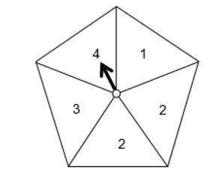
Joanne has a fair five sided spinner. Work out the probability of scoring an even total with two spins.

Three friends Ann (A), Bob (B) and Carol (C) go on holiday together.
They book a row of three seats on a plane.
When they arrive at the plane they sit in a random order.

What is the probability that Ann and Carol sit next to each other?

What is the probability that Bob sits in seat 1 with Ann next to him?

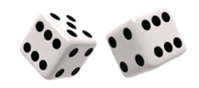
Is the game fair?

Two dice are rolled and the numbers on each dice are subtracted (smaller from larger).

If the difference is 1 or 2 Anton wins
If the difference is 3, 4 or 5 Brisa wins

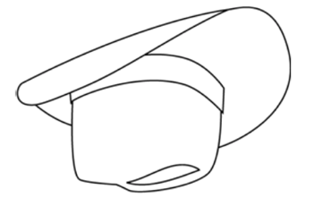
One of each of the numbers 2, 3, 4, 5, 6 and 8 is put into a hat.
One number is pulled out, then another (not replacing the first).
The score is the total of the two numbers.

If the total is even Alfie wins
If the total is odd Bella wins


Andrew is playing a game and picks a card from a normal pack of playing cards.
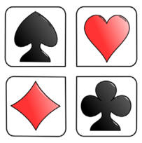
He records whether he gets a heart, club, diamond or spade.

At the same time he throws a normal six sided dice and records the
number it lands on.

If he gets a heart and rolls a multiple of 3 he wins a prize.
- What is the chance he wins?
- What is the chance he loses?

