L.Q. What are resultant vectors and how do I find them? | Date:
L.Q. What are resultant vectors and how do I find them? | Name:
Combining Vectors
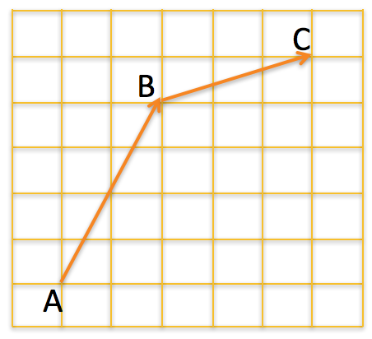
19.9

Show the resultant vector is the sum of the vectors shown:
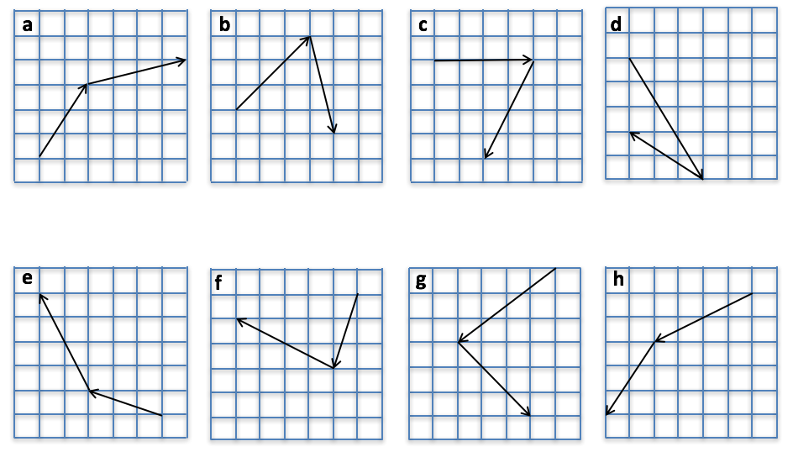

Calculate these resultant vectors:
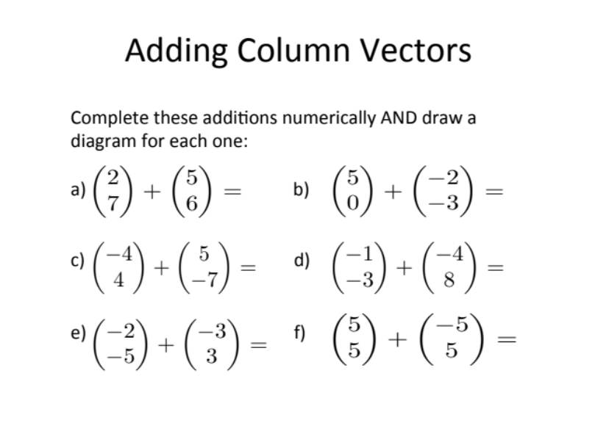

Parallel Vectors |  |  |  |  |  |  |  |  |  | Negative Vectors

Subtracting Vectors
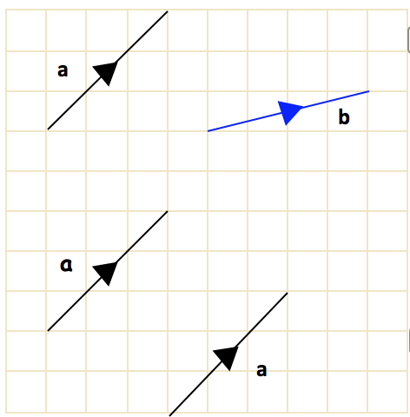

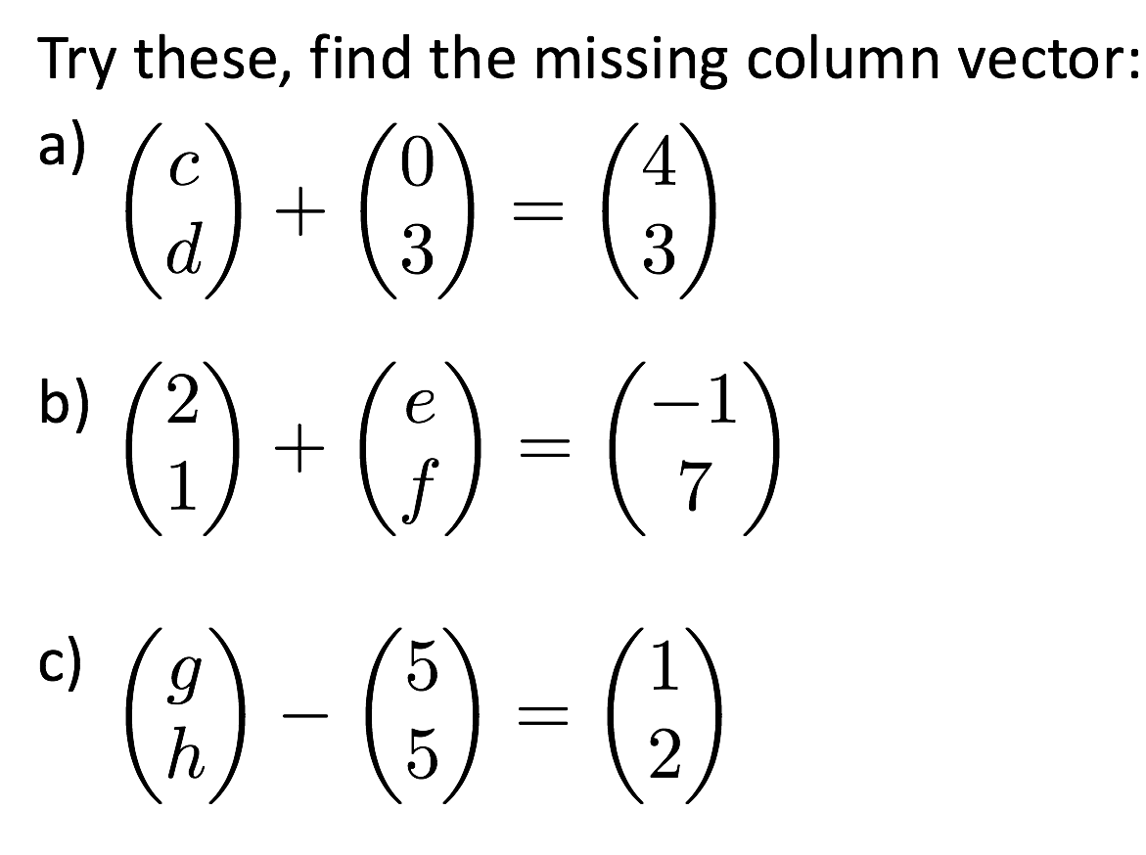
Complete these vector subtractions

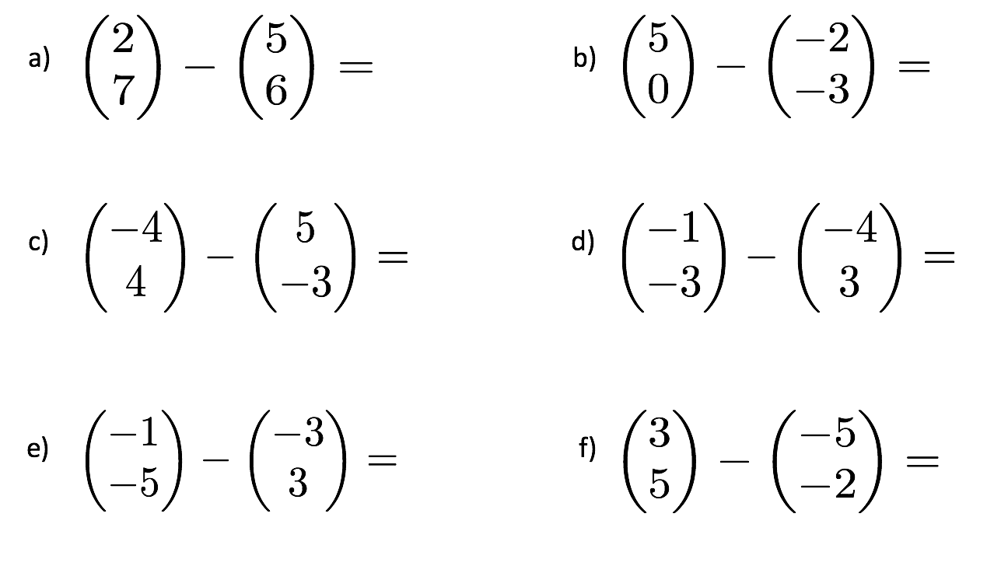

Multiplying Vectors

$a=\left(\begin{aligned} \\ \end{aligned}\right)$ $2a=\left(\begin{aligned} \\ \end{aligned}\right)$

$b=\left(\begin{aligned} \\ \end{aligned}\right)$ $3b=\left(\begin{aligned} \\ \end{aligned}\right)$

$c=\left(\begin{aligned} \\ \end{aligned}\right)$ $-4c=\left(\begin{aligned} \\ \end{aligned}\right)$
