Find the nth term for the sequence:

5, 9, 13, 17, 21

1. | 5, 9, 13, 17, 21
2. | 5, 9, 13, 17, 21
3. | 5, 9, 13, 17, 21

Find the nth term of these sequences:

3, 5, 7, 9, 11
4, 7, 10, 13, 16
5, 8, 11, 14, 17
2, 10, 18, 26, 34
11, 9, 7, 5, 3
27, 17, 7, -3, -13
2, 2.5, 3, 3,5, 4
1.4, 2, 2.6, 3.2, 3.8

Problem solving with the nth term:

Find the nth term for this sequence of patterns:
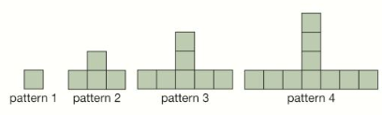

Eliza says “There will be 20 squares in the 8th diagram because there are 10 squares in the 4th diagram.” Do you agree? Explain your reasons.

Esme says “There is a pattern with 345 squares.”
Do you agree? Explain your reasons.

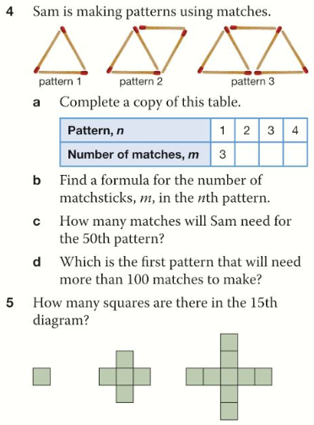 | Will there be a pattern with 199 squares?

Just Maths Exit Card

