L.Q. How do I group data into class intervals and draw histograms? | Date:
 | Name:
16.2

Continuous data | Class intervals

Copy and complete the frequency table using these masses of people, given to the nearest kilogram.
48 63 73 55 59 61 70 63 58 67
46 45 57 58 63 71 60 47 49 51
53 61 68 65 70 60 52 59 50 49
48 47 63 61 58 71 53 51 60 70
Mass (kg) | Tally | Frequency
$$45≤w<50$$
$$50≤w<55$$
$$55≤w<60$$
$$60≤w<65$$
$$65≤w<70$$
$$70≤w<75$$

Histogram | Properties

Draw a histogram to show the data:

The heights of people are recorded. Complete the frequency table and draw a histogram.
153 134 155 142 140 163 150 135
170 156 171 161 141 153 144 163
140 160 172 157 136 160 134 154
176 154 173 179 160 152 170 148
151 165 138 143 147 144 156 139
Height (h) | Tally | Frequency
$$130<h≤140$$
$$140<h≤150$$
$$150<h≤160$$
$$160<h≤170$$
$$170<h≤180$$

This chart shows the best distances in metres that athletes threw a javelin in a competition.
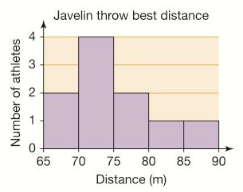
- State the number of athletes who threw the javelin:
i) between 65 and 70 metres
ii) between 80 and 90 metres
- In which class interval was the winner?
- Calculate the total number of athletes who threw a javelin.

Ali surveyed 40 students to find out how much time they spent doing homework in the past two weeks.
Complete the table, finding the value of x, and complete the histogram.
Homework hours (t) | Frequency
$$0≤w<5$$
$$5≤w<10$$ | x
$$10≤w<15$$
$$15≤w<20$$ | 13
$$20≤w<25$$ | 2x
$$70≤w<75$$

