L.Q. How do I calculate the missing edge of a right angled triangle? | Date:
 | Name:

Just Maths Follow me activity

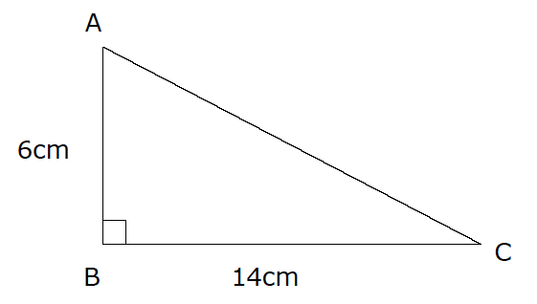
Longest Edge:

S
S
A
S
Pythagoras’ Theorem:

Calculate the longest edge:  7cm  5cm | 3.9m  6.8m |  | 18.2m  5.8m
A square has sides of length 10cm.  Find the lengths of its sides. |  | Calculate the distance between the coordinates (1, 3) and (4, 7)
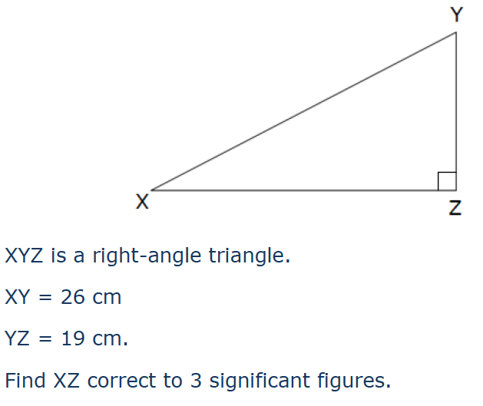
Shorter Edge:

S
S
S
S
longest edge is

Calculate the shorter edge:  19.5cm  3.2cm | 3.9m  6.8m | 49m  63m

Decide whether you’re calculating the longest or a shorter edge:

15cm  12cm | 25mm  65mm | 7m  25m

Calculate the length of the diagonal of the rectangle:  34cm  45cm | Calculate the height of the triangle:  10.5cm  3cm  14cm | Calculate the base of the triangle:  12cm  8cmm

