L.Q. How do I calculate and use the area of a  and a | Date:
L.Q. How do I calculate and use the area of a  and a | Name:
Area of a parallelogram
5cm

10cm

7cm

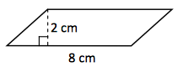 |  | 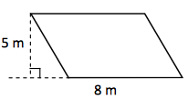 |  |  | 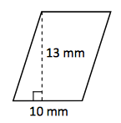
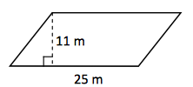 |  | 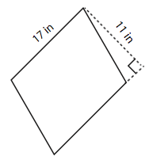 |  |  | 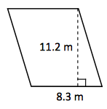
- UNITS!!  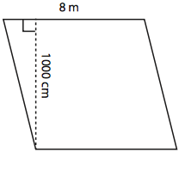 |  |  | 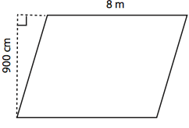
- MISSING LENGTH  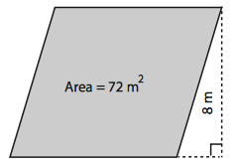 |  |  |  | 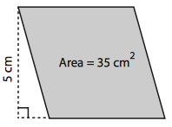

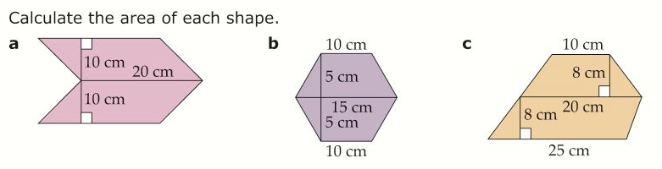
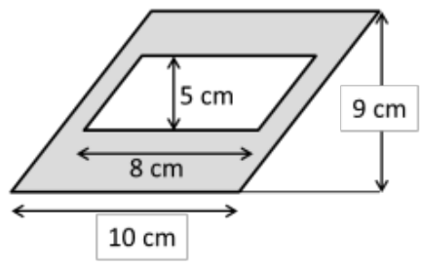
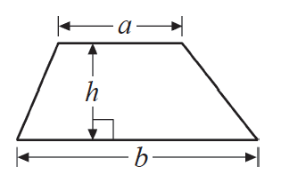
5 cm
4 cm
3 cm
5 cm
Area of a trapezium = $\frac{1}{2}\left(a+b\right)$

5 cm
7 cm
3 cm
6 cm

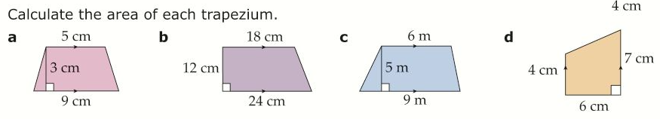


Here is a diagram of Jim’s garden to make a lawn.
Jim wants to cover his garden with grass seed.
Grass seed is sold in bags.
There is enough grass seed in each bag to cover 20m² of garden.
Each bag of grass seed costs £4.99.
Work out the least cost of putting grass seed on Jim’s garden.
