L.Q. How do I relate an equation to its graph? | Date:
L.Q. How do I relate an equation to its graph? | Name:
18.2
Select the equation that matches the description, and sketch the graph.
Choose the correct description for the graph.
Equations:

y = x

y = 2

y = -x

x = -2

Graph descriptions:

HORIZONTAL

VERTICAL

POSITIVE DIAGONAL

NEGATIVE DIAGONAL
Description | Equation | Graph
The x co-ordinate is always equal to -2.
Eg. (-2, 4) (-2, -3)
The y co-ordinate is always equal to 2.
Eg. (-2, 4) (-2, -3)
The y co-ordinates are always equal to the x co-ordinates.
Eg. (1, 1) (-4, -4)
The y co-ordinates are always equal to the negative x co-ordinate.
Eg. (3, -3) (-2, 2)
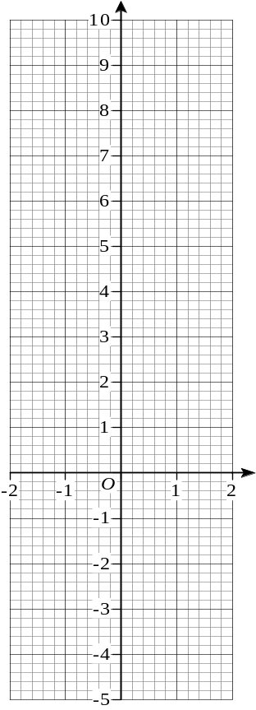
Draw the graph for given by the equation y = 2x + 3, for the values of x between -2 and 3.

Now draw the following graphs, for the values of x between -2 and 3:

- y = 3x – 2
- y = 2x – 1
- y = ½x + 3

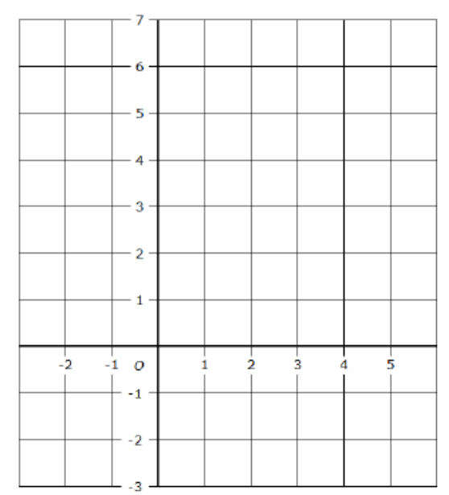
Draw the graph of x + y = 5 for the values of x between -2 and 5.

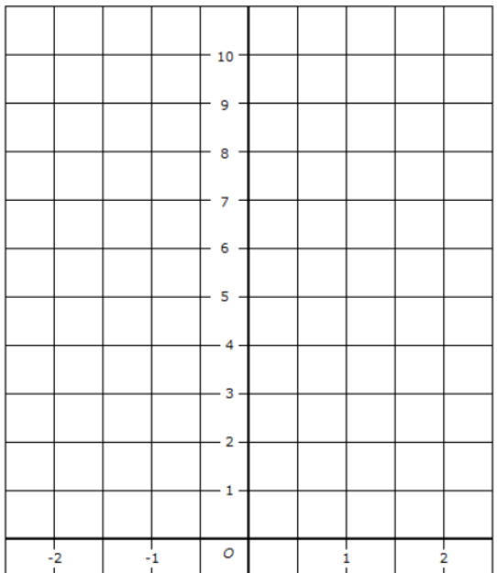

Draw the graph of y = 6 – 2x for the values of x between -2 and 2.


2) On the grid, draw the graph of y = 2x − 3 for values of x from −2 to 3

