Sort the numbers 1 to 12 into the Venn diagram:
A = Multiples of 3
B = Odd numbers
A
B
SET | ELEMENTS | UNIVERSAL SET

List the elements of these sets:

P = {the first ten positive integers}

Q = {single digit odd numbers}

R = {the first ten square numbers}

S = {prime numbers smaller than 20}

You can use a Venn diagram to show relationships between sets:
b
A | A$∩$B | A$∪$B | A’
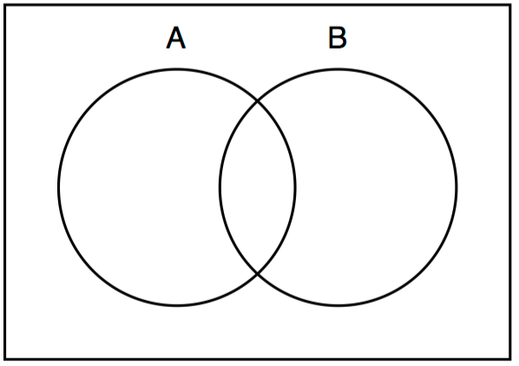

Using the sets P, Q, R, S, give the following sets:
Q $∩$ S
Q $∪$ S
Q $∩$ R
P$∪$ R
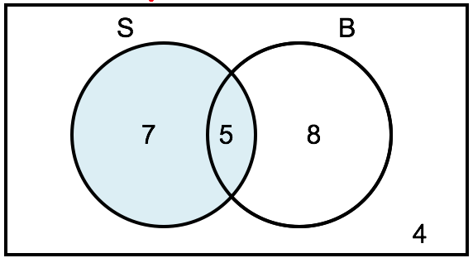
Work out p(S$∩$B)

Work out p(B’)

Work out p(S$∪$B)

Mrs Smith asks her students about their families. She sorts them into:
S={has sisters}
B={has brothers}
She showed her results in a Venn diagram.

Describe the shaded region in words.

Describe the region S $∩$ B in words.

How many students are is S’?

Using numbers 1 to 10, complete this Venn diagram
E
S
E = {Even numbers}
S = {Square numbers}
Shade in the region that has a square numbers that are not even.
Describe the region E $∪$ S in words.

How many numbers are in E’?

Work out p(E$∩$S)

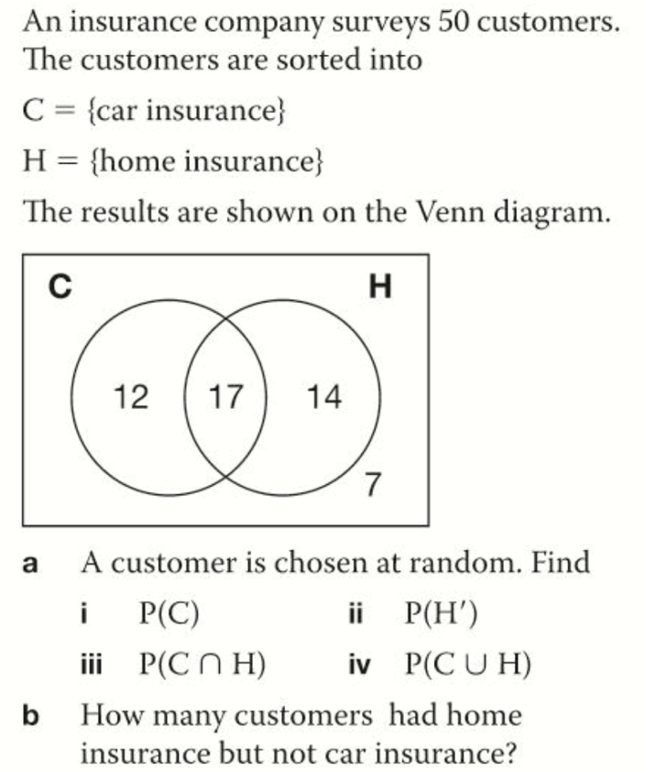
Work out p(S’)

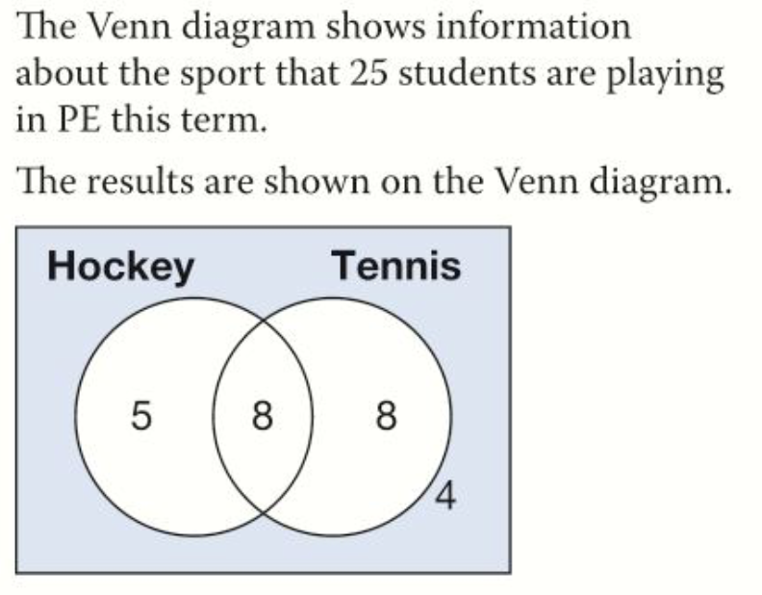
What is the probability:
- A student pays hockey and tennis
- A student plays hockey
- A student does not play tennis
- A student plays hockey or tennis

