L.Q. How do I calculate the perimeter and area of compound shapes? | Date:
 | Name:

Perimeter

Neil wants to put a fence all the way around his pond.
How much fencing does he need?
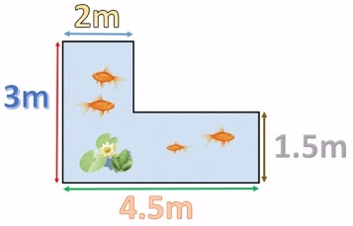
Area

Neil wants to put a cover on his pond. What is the area of the surface of his pond?

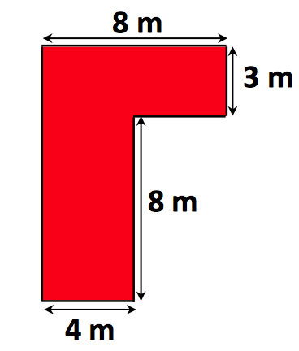 |  | 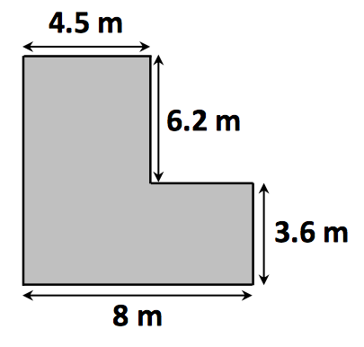
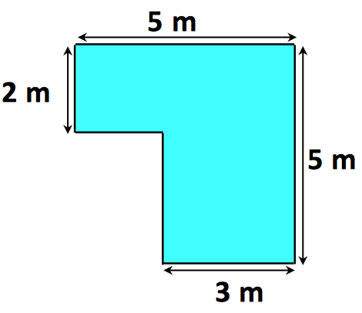 |  | 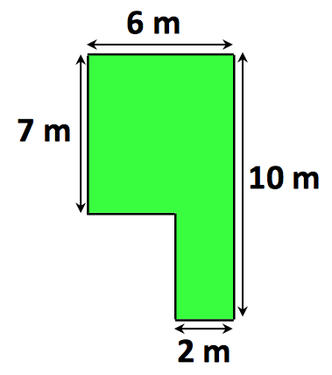
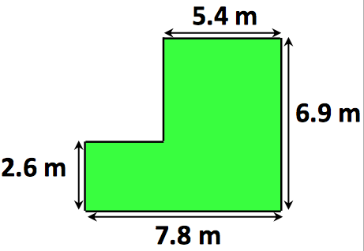
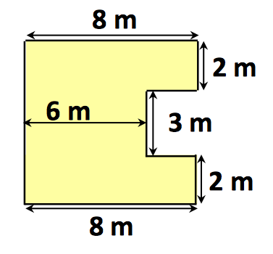 |  | 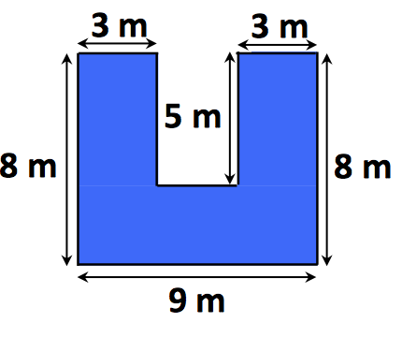

The diagram shows the plan of the floor of Mrs Phillips' living room.
4 marks
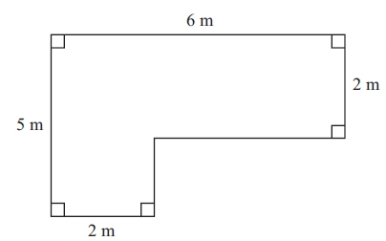
Mrs Phillips is going to cover the floor with floor boards.
One pack of floor boards will cover 2.5 m².
How many packs of floor boards does she need?
You must show your working.

∗The diagram shows the plan of a small field.
4 marks
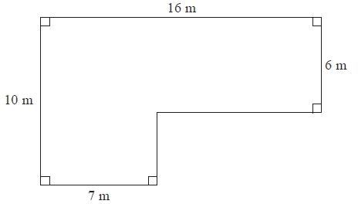
Kevin is going to keep some pigs in the field.
Each pig needs an area of 36 square metres.
Work out the greatest number of pigs Kevin can keep in the field.

* The diagram shows the floor of a village hall.
5 marks
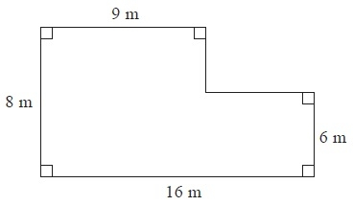
The caretaker needs to polish the floor.
One tin of polish normally costs £19
One tin of polish covers 12 m² of floor.
There is a discount of 30% off the cost of the polish.
The caretaker has £130. Has the caretaker got enough money to buy the polish for the floor?
You must show all your working.

