L.Q. How do I interpret an equation of a graph? | Date: | 18.3
L.Q. How do I interpret an equation of a graph? | Name:

$$y=mx+c$$

Equation | Gradient | y-intercept |  | Equation | Gradient | y-intercept
$$y=9x+7$$ |  |  |  | $$y=2-7x$$
$$y=\frac{1}{2}x-3$$ |  |  |  |  | $$\frac{1}{3}$$ | $$(0,-3)$$
$$y=x+23$$ |  |  |  | $$y=1+2x$$
 | $$3$$ | $$(0,1)$$ |  | $$y=10-x$$
 | $$-2$$ | $$(0,-3)$$ |  |  | 6 | $$(0,0)$$
$$y=-5x$$ |  |  |  |  | $$0$$ | $$(0,4)$$

Draw the graph of $y= 2x+4$ for the values of $x$ between -3 and 3:
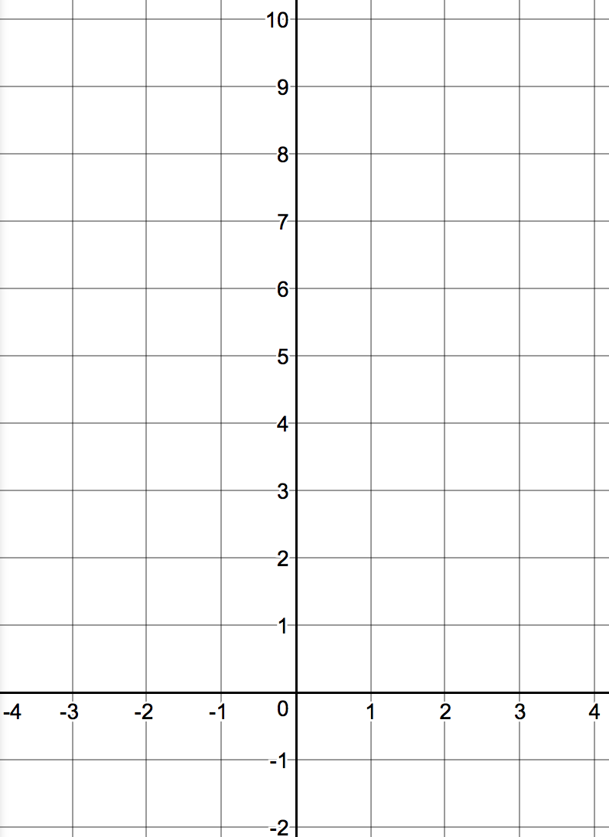
x | -3 | -2 | -1 | 0 | 1 | 2 | 3
y

Gradient

y-intercept

Line 2:

Gradient
y-intercept | Equation

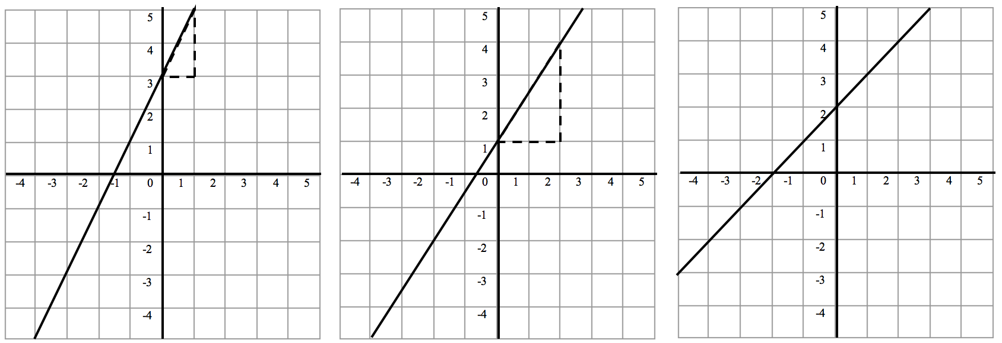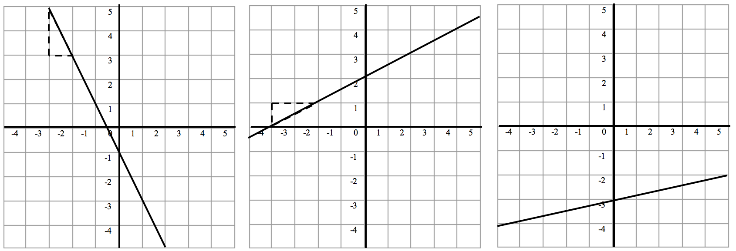
Gradient =
y-intercept =
Equation =
Gradient =
y-intercept =
Equation =
Gradient =
y-intercept =
Equation =
Gradient =
y-intercept =
Equation =

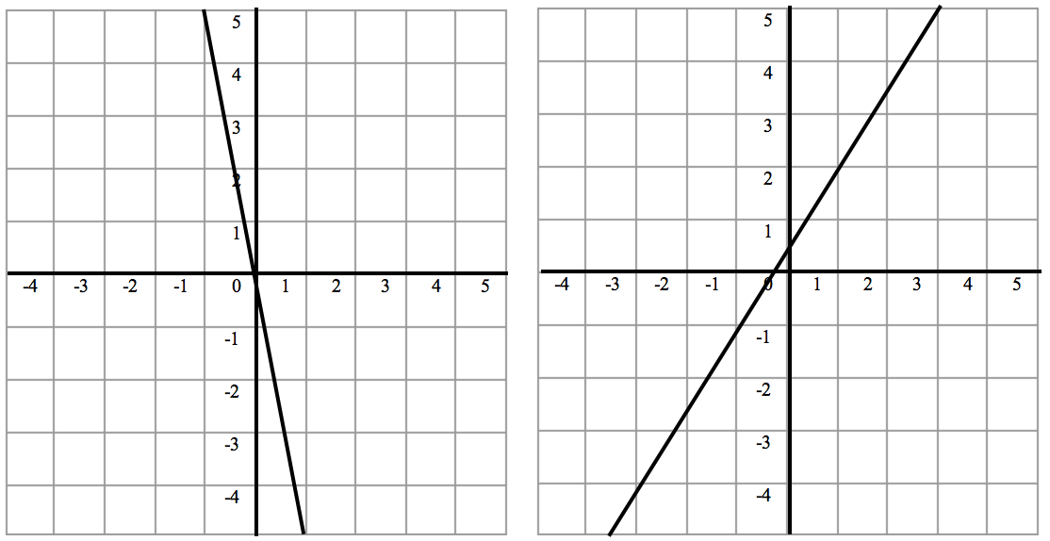
Gradient =
y-intercept =
Equation =
Gradient =
y-intercept =
Equation =
Gradient =
y-intercept =
Equation =
Gradient =
y-intercept =
Equation =

Gradient =
y-intercept =
Equation =
Gradient =
y-intercept =
Equation =
Gradient =
y-intercept =
Equation =
Find the equation of a line  That passes through $(1,2)$ and $(3,4)$ | Find the equation of a line  That passes through $(2,0)$ and $(4,1)$ | Find the equation of a line  That passes through $(1,4)$ and $(2,2)$
Gradient

y-intercept

Equation =
Gradient

y-intercept

Equation =
Gradient =

Substitute gradient and one set of co-ordinates into $y=mx+c$

Equation =

