L.Q. How do I measure and calculate bearings? | Date:
L.Q. How do I measure and calculate bearings? | Name:
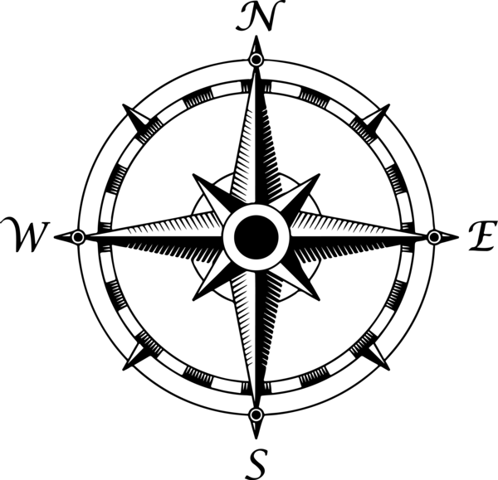
The three rules of bearings:
1.
2.
3.
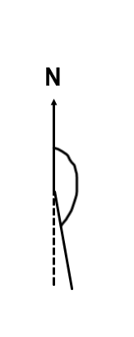
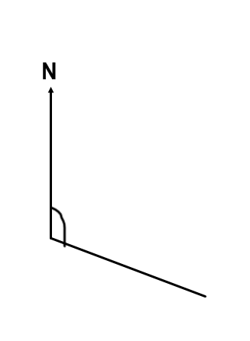
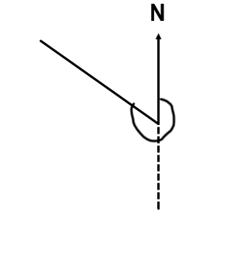
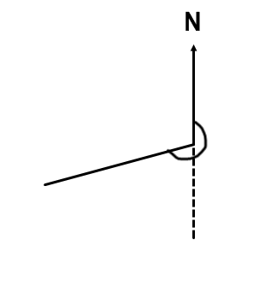
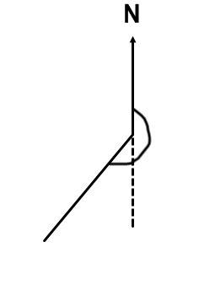
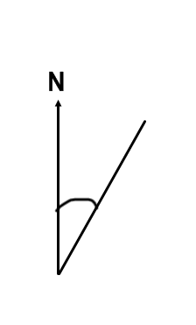
Use a protractor to find the size of these bearings:

Draw the following bearings from X, using a scale of 1cm:1m.
A at a bearing of 030º and 5m away
B at a bearing of 100º and 8m away
C at a bearing of 200º and 6.5m away
D at a bearing of 305º and 4m away

X
A ship is on a bearing of 050º from lighthouse A, and on a bearing of 320º from lighthouse B. Find the position of the ship and label it C.

A

B

A distress flare is spotted from two different points. Point A records the sighting on a bearing of 058º. Point B records the sighting on a bearing of 275º. Find the location of the distress flare.
B

A

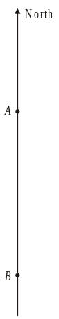
A is due North of B. The bearing of C from A is 115°.
The bearing of C from B is 075°.
Mark the position of C on the diagram.

Back bearings: getting back to the starting point:
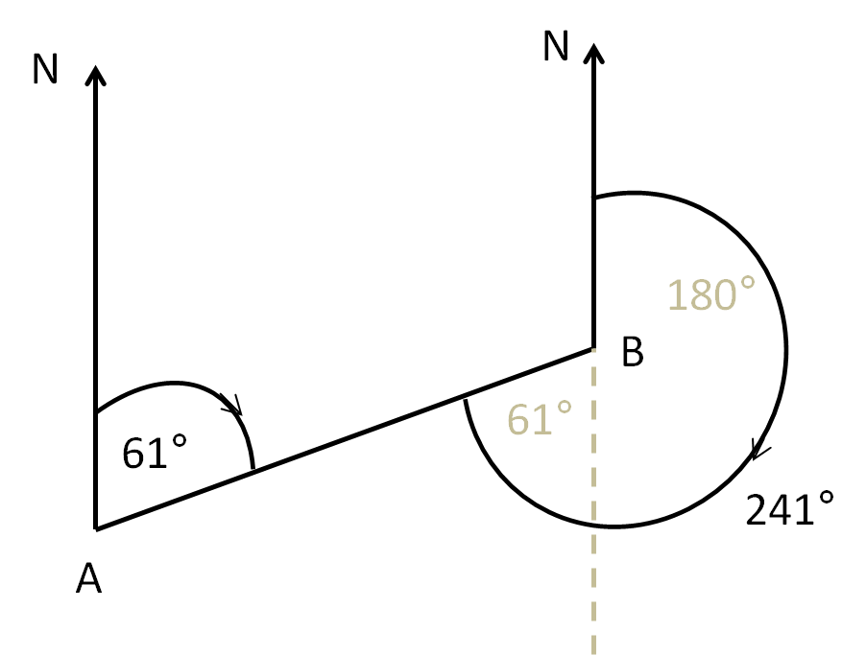

What is the back bearing for the following:
- 045º
- 096º
- 107º
- 180º
- 200º

