L.Q. How do I calculate the circumference of a circle? | Date:
L.Q. How do I calculate the circumference of a circle? | Name:
Radius | Diameter
5cm
47cm
 | 30cm
 | 11cm
8cm
4.5cm
 | 74cm
 | 13cm

CIRCUMFERENCE

11m
A circle has diameter 11m.
Work out the circumference of the circle.
Give your answer correct to one decimal place.

8cm

A circle has radius 8cm.
Work out the circumference of the circle.
Give your answer correct to 3 significant figures.

Work out the circumference of these circles:

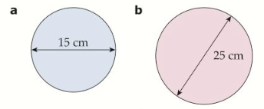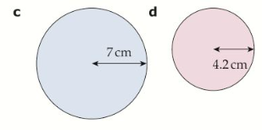

Just Maths “What’s the phrase” activity

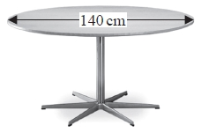
* Saphia is organising a conference.
People at the conference will sit at circular tables.
Each table has a diameter of 140 cm.
Each person needs 60 cm around the circumference of the table.
There are 12 of these tables in the conference room.
A total of 90 people will be at the conference.
Are there enough tables in the conference room?
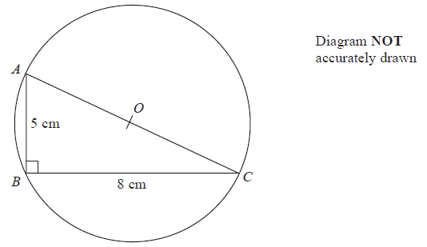
AOC is a diameter of the circle.
Calculate the circumference of the circle.
Give your answer correct to 3 significant figures.

