Frequency Tree

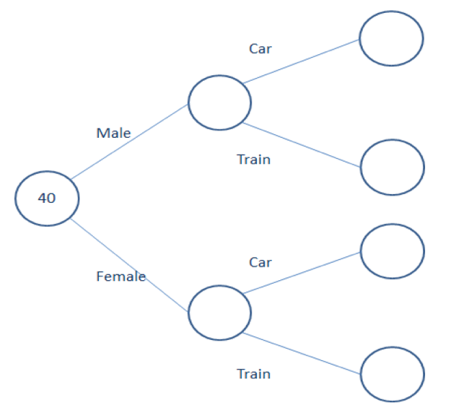
There are 40 people at a meeting.
Each person travelled to the meeting either by
car or by train.
13 of the people are male.
15 people travelled by train.
8 males travelled by car.

Work out the total number of people who travelled by car.

Just Maths Nailed it, mastered it tasks

Probability Tree

A menu has the following items: Main Course Pudding

Main Course: Pudding:
Fish and chips Ice cream
Lasagne Fruit Salad

A customer chooses one main course and one pudding item.
The probability of choosing fish and chips is 0.4.
The probability of choosing Fruit salad is 0.15

Draw a probability tree to show the possible outcomes.

Hubert has 10 coloured counters in a bag. 3 of the counters are blue and 7 of the counters are green.
He removes a counter at random from the bag and notes the colour before replacing it.
He then chooses a second counter.
Record the information on a tree diagram.

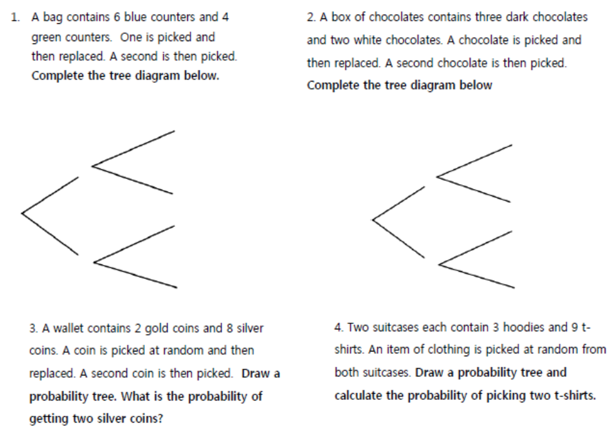

Red =

Green =

DOES NOT REPLACE (or eats it)

Hubert has 10 coloured counters in a bag. Three of the counters are blue and seven of the counters are green. He removes a counter at random from the bag and notes the colour and does not replace it. He then chooses a second counter. Record the information on a tree diagram.

1. Lucy has a box of 30 chocolates. 18 are milk chocolate and the rest are dark chocolate. She takes a chocolate at random from the box and eats it. She then chooses a second.
Draw a tree diagram to show all the possible outcomes

2. Jimmy has five coloured counters in a bag. Two of the counters are blue and the rest are red. He removes a counter at random from the bag and notes the colour but does not replace it. He then chooses a second counter. Draw a tree diagram showing all possible outcomes.

