L.Q. How do I solve problems involving the area of a circle? | Date:
L.Q. How do I solve problems involving the area of a circle? | Name:
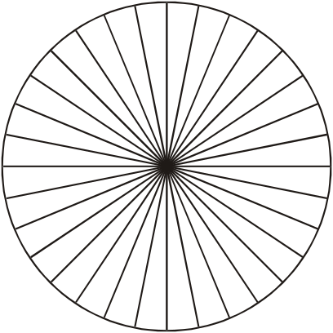
AREA

8cm
A circle has radius 8cm.
Work out the area of the circle.
Give your answer correct to 3 significant figures.

11m

A circle has diameter 11m.
Work out the area of the circle.
Give your answer correct to one decimal place.

Work out the area of these circles:

4m
12cm
49mm
3.5cm
1.
2.
3.
4.

Just Maths “What’s the phrase” activity

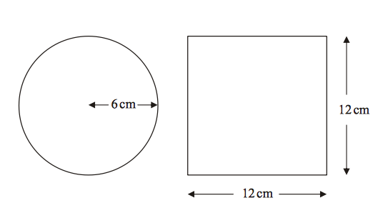
A circle has a radius of 4cm.
A square has a side length of 12cm.
Work out the difference between the area of the circle and the area of the square.
Give your answer to one decimal place.

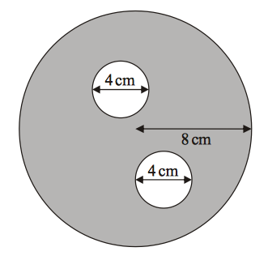
The diagram shows two small circles inside a large circle.
The large circle has a radius of 8cm.
Each of the two small circles has a diameter of 4cm.
- Write down the radius of each of the small circles.
- Work out the area of the region shown shaded in the diagram. Give your answer to one decimal place.

