AND RULE

- A bag contains 5 red balls, 4 yellow balls and 3 green balls. If I pick two balls out of the same bag (replacing the first ball before I pick the second), what is the probability of the following?
- A red ball and a green ball b. A yellow ball and a green ball

- Two red balls d. Two green balls

- I roll a dice and toss a coin at the same time. What is the
probability of the following outcomes?
- A ‘2’ and a head b. An odd number and a tail c. A number less than 3 and a head

- A school canteen offers a choice of main course and pudding.
Main: Roast chicken (0.7) or Vegetarian Pasta
Pudding: Fruit (0.25) or Cake
What is the probability of a student picking the following?
  - Roast chicken and fruit b. Vegetarian pasta and fruit d. Roast chicken and cake

AND RULE and probability trees

A bag contains 5 green and 3 red balls. A ball is taken from the bag at random and replaced. Another ball is then taken from the bag at random. Complete the tree diagram.

What is the probability that both balls are red?

What is the probability that the balls are different colours?

Seb has a biased dice.
When the dice is thrown once, the probability that it will land on 6 is $\frac{3}{5}$.
Seb is going to throw the dice twice.
(a) Complete the probability tree diagram.
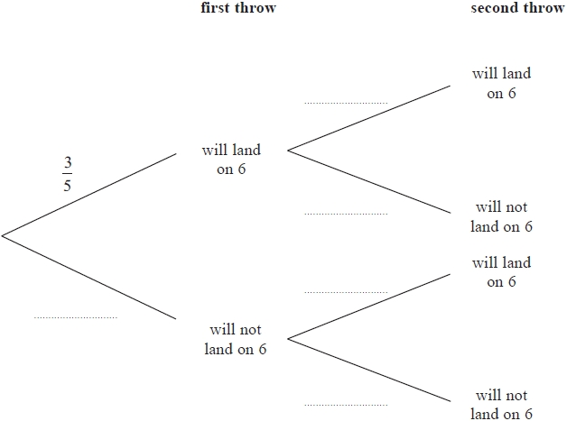
(b) Work out the probability that the dice will land on 6 on the first throw and will not land on 6 on the second throw.

(c) Work out the probability the dice will land on a 6 at least once.
(Hint: add up all the probabilities where a 6 is possible).

Q2. Louise makes a spinner.
The spinner can land on green or on red.
The probability that the spinner will land on green is 0.7
Louise spins the spinner twice.
(a) Complete the probability tree diagram.
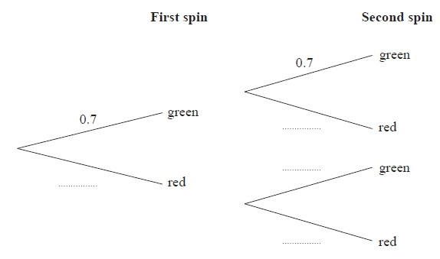

(b) Work out the probability that the spinner lands on red twice.

(c) Work out the probability that the spinner lands on two different colours.

Q3. There are 10 socks in a drawer.
7 of the socks are brown.
3 of the socks are grey.
Bevan takes at random two socks from the drawer at the same time (they are not replaced).
(a) Complete the probability tree diagram.

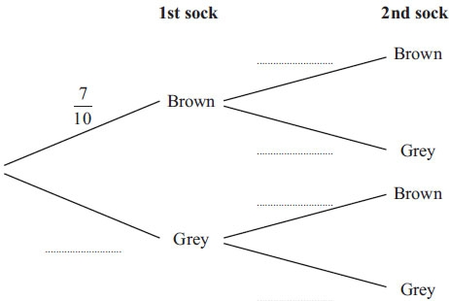
(b) Work out the probability that Bevan takes two socks of the same colour.
(c) Work out the probability that Bevan takes at least one grey sock.

Q4. Martin and Luke are students in the same maths class.
The probability that Martin will bring a calculator to a lesson is 0.8
The probability that Luke will bring a calculator to a lesson is 0.6
(a) Complete the probability tree diagram.
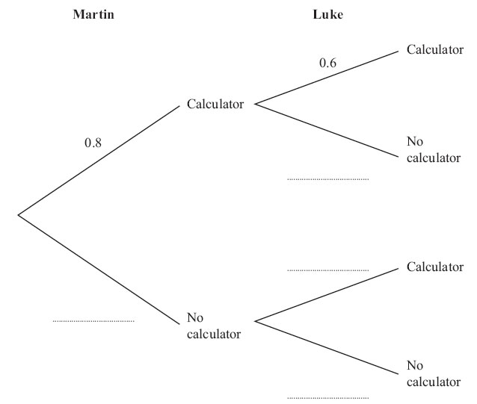
(b) Work out the probability that both Martin and Luke will not bring a calculator to a lesson.

