L.Q. How do I solve problems about quadratic graphs? | Date: | 18.5
L.Q. How do I solve problems about quadratic graphs? | Name:

Complete the table of co-ordinates for the equation $y=x^{2}+2x-1$
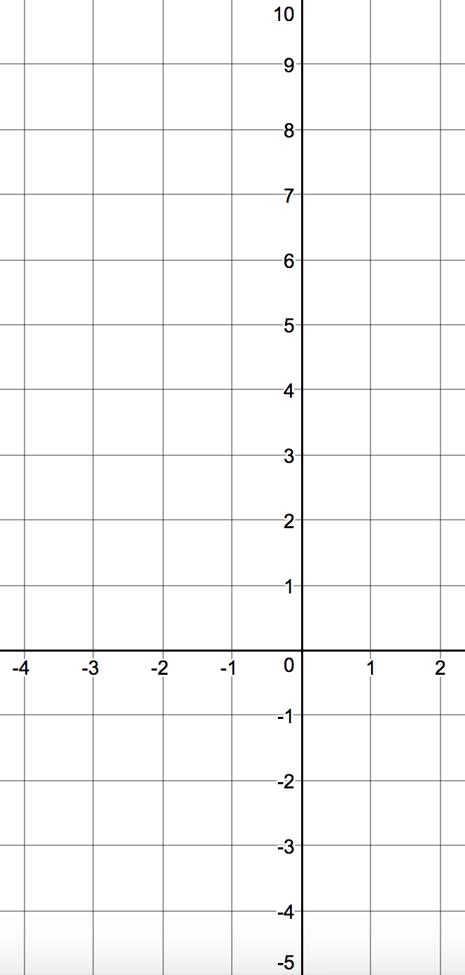
$$x$$ | -4 | -3 | -2 | -1 | 0 | 1 | 2
$$y$$ |  | 3 |  | -3 | -1

Draw the graph on the axes:
Turning point:

Find the roots of the function $x^{2}+2x-1=0$
Roots:

Find the the roots for the function $x^{2}-4x=0$

Draw the graph first:
$$y=x^{2}-4x$$
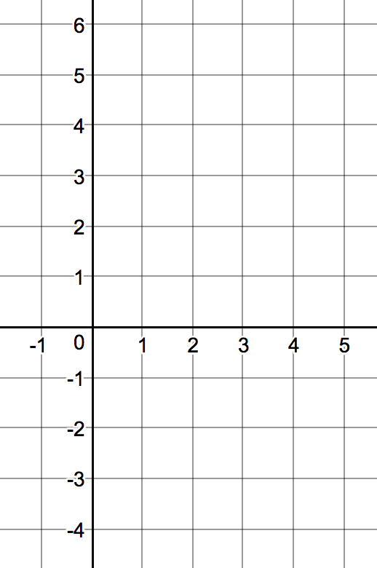
$$x$$ | -1 | 0 | 1 | 2 | 3 | 4 | 5
$$y$$

Find the roots for the function $f\left(x\right)=0$
Find the roots for the equation

$3+2x-x^{2}=0$

$$x$$ | -2 | -1 | 0 | 1 | 2 | 3 | 4
$$y$$

$f\left(x\right)={2x}^{2}-5$

$$x$$ | -2 | -1 | 0 | 1 | 2
$$y$$

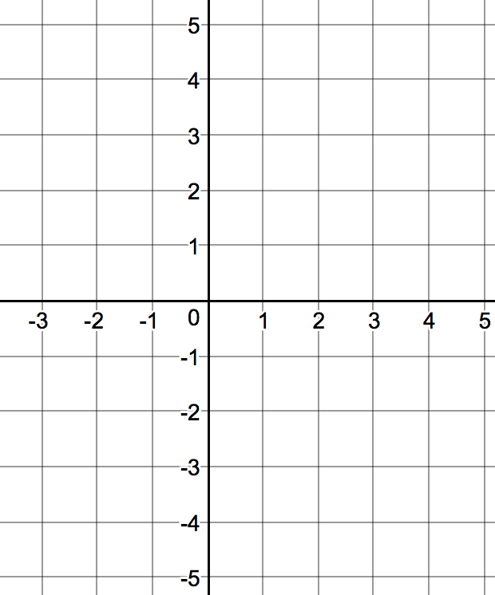


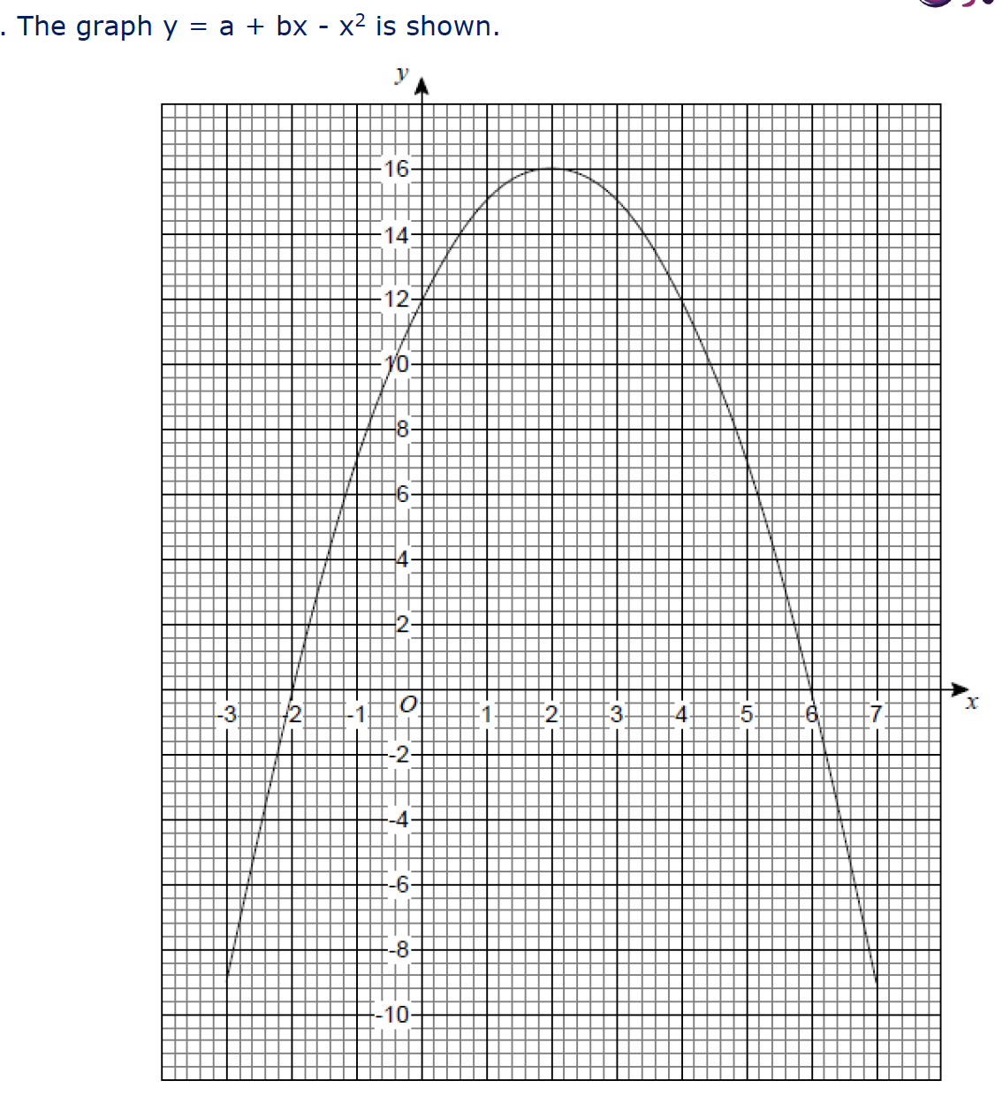


Why did you choose each answer?

a)

b)

c)

