L.Q. How do I find a missing side on a right angled triangle using trig ratios? | Date:
 | Name:
19.5

How do trig ratios help us?
1.
2.
3.
4.

Just Maths Boarding Card

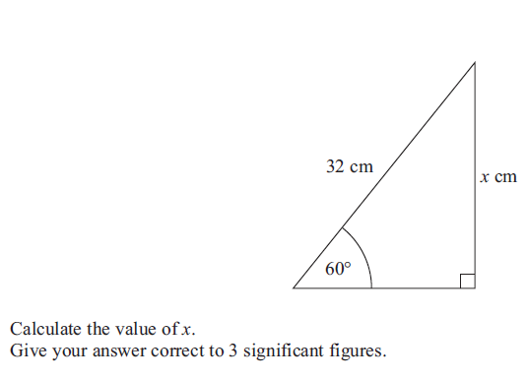

Just Maths “must, should could” MUST activity

50º
$$x$$
10cm
25º
$$x$$
4.5m

Just Maths “must, should could” SHOULD activity


COULD:

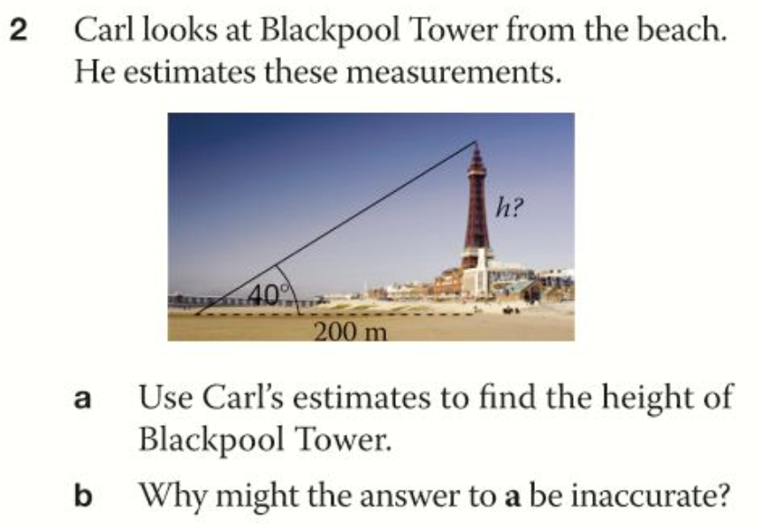
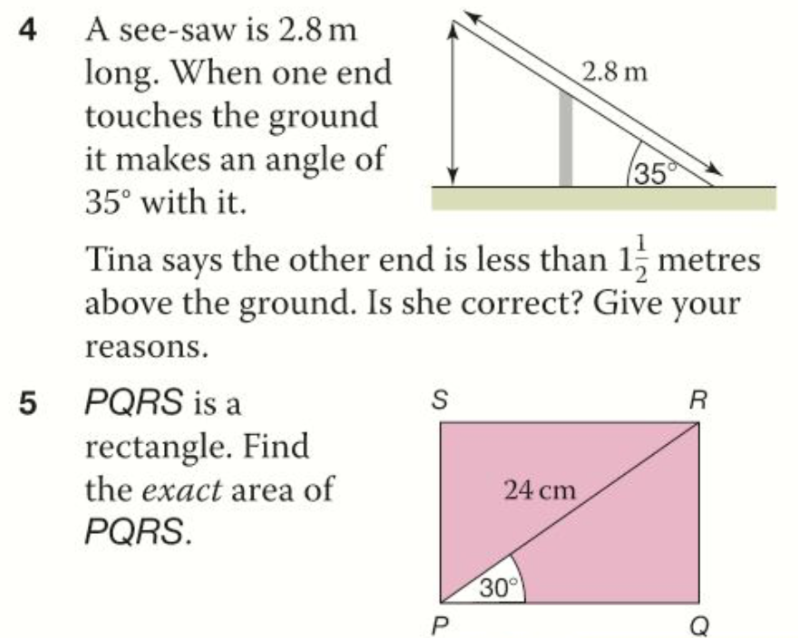

How can we solve trig questions without a calculator?
$30$º
$1$cm
$60$º
$2$cm
$45$º
$45$º
$1$cm
$1$cm
Use Pythagoras to find the 3rd side. Leave in form.

Use Pythagoras to find the hypotenuse. Leave in form.

We can work out exact trig values for these angles:

 |  | 0º | 30º | 45º | 60⁰ | 90º
$$\frac{opposite}{hypotenuse}$$ | Sin
$$\frac{adjacent}{hypotenuse}$$ | Cos
$$\frac{opposite}{adjacent}$$ | Tan

Work out the value of $x$ (non-calculator).
