L.Q. How do I use ruler, protractor and compass to construct with triangles? | Date:
 | Name:

For each triangle, start __________________________

Angle Side Angle

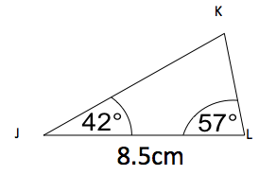
Measure the
___________
next, using a
___________
Side Angle Side
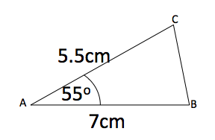
Measure the
___________
next, then use a
__________ for
the second side.
Side Side Side

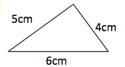
Use a ________
to draw an arc for
the other two sides.
Skills Practice
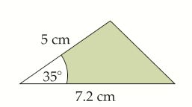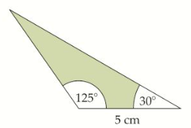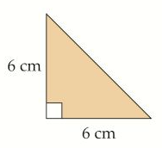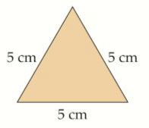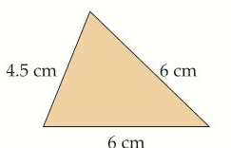

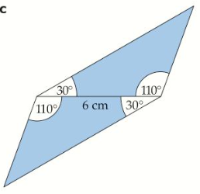
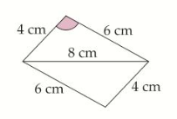
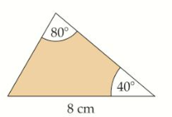
Problem Solving

Draw triangle ABC, where angle A = 38º, B = 60º and AB = 6cm (draw a sketch first).

