$$π$$

Simplify these expressions:

- $π+π=$  - $2π+π=$  - $4+π-2+π=$  - $π\left(4^{2}-6\right)=$  - $2π\left(3^{2}-7\right)=$  - $4π\left(2+\sqrt{4}\right)=$  - $\frac{48π}{4}=$  - $3×\left(7-\sqrt{9}\right)π=$ | - $2π\left(3-2π\right)+{\left(2π\right)}^{2}=$  - $π^{2}-π\left(π-4\right)=$  - $\frac{1}{3}π-\frac{1}{6}π=$  - $\frac{1}{3}\left(\frac{3}{4}-\frac{π}{2}\right)=$

Find the area or circumference of each circle and shade the answer in on the grid.

Area of circle radius 5 | Circumference of circle diameter 10 | Circumference of circle radius 10 | Area of circle radius 3
Area of circle diameter 8 | Area of circle diameter 4 | Circumference of circle radius 3 | Circumference of circle diameter 5
Area of semicircle radius 2 | Area of semi circle radius 4 | Area of semi circle diameter 12

$$16π$$ | $$5π$$ | $$6π$$ | $$8π$$ | $$9π$$
$$π$$ | $$25π$$ | $$28π$$ | $$2π$$ | $$36π$$
$$64π$$ | $$18π$$ | $$24π$$ | $$4π$$ | $$12π$$
$$3π$$ | $$10π$$ | $$30π$$ | $$20π$$ | $$100π$$

Using $π$ in problems

Joshua’s bicycle wheel has a diameter of 0.4m. On his journey to work it rotates 5000 times. Write an exact expression for how far he travels.
Kim’s wheel has a radius of 35cm and it rotates 4000 times. Which expression is correct for how far she travels?
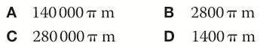
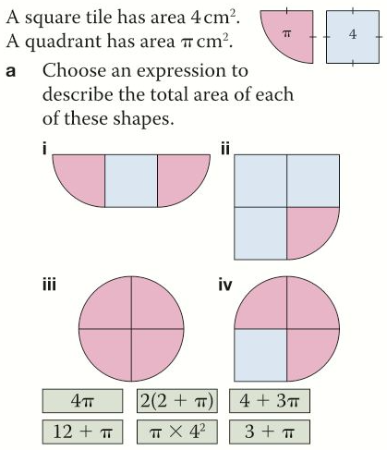
A tin can has diameter 8cm and height 10¾ cm. Work out:
- The circumference
- The curved surface area
- The area of the base
- The volume of the can
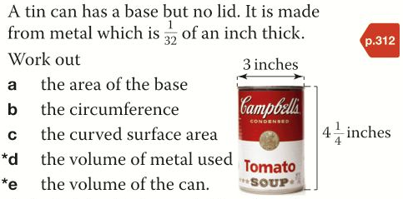
10¾ cm
8 cm

