Answer these questions:

Set 1  5 x 10 =  5 x 10 x 10 =  5 x 10 x 10 x 10 = | Set 2  10¹ =  10² =  10³ = | Set 3  5 x 10¹ =  5 x 10² =  5 x 10³ =

Large numbers in standard form:

37000000 ________ x 10 _____

  The Satellite moves at 2.5 x 10⁴ km per hour |  |   Jon’s rocket flies at 3.65 x 10⁶mph
Solomon is space walking    2.3 x 10⁷ metres from home. |  |   Helios 2 Space Probe travelled at  2.41 x 10⁸ metres per hour in 1976
  The satellite has a mass of 3.76 x 10⁴ tonnes |  |   Zkfuryzx’s space craft travels at 4.87 x 10³ metres per second
  The Shuttle has a total of 1.2 x 10⁷ lightbulbs |  |   The mass of Haley’s comet is estimated at 1.7 x 10¹⁵ kg
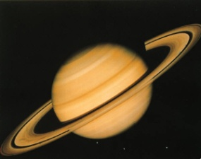  Saturn is 1.21 x 10⁵ km in diameter |  | 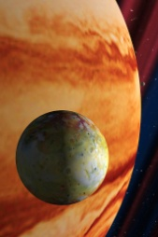  Jupiter is 1.43 x 10⁵ km in diameter
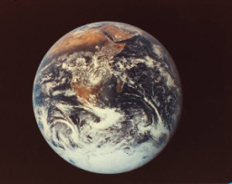  Earth’s circumference is about  4.02 x 10⁴ km |  | 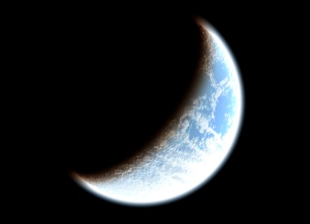  The Moon is 2.388 x10⁵ km away from earth
Write these as ordinary numbers and then in standard form:

5km in cm

12litres in ml

4.6kg in g

1.72km in mm

Number | Number in standard form
1 000 000 000 | 1 x 10⁹
12 000 000 | 1.2 x 10⁷
15 000
99 000
12 000 000 000 000
10 000 000 000 000 000
99 000 000 000 000 000
155 000 000
1 380 000 000
22 000 000

Set 4  5 ÷ 10 =  5 ÷ 10 ÷ 10 =  5 ÷ 10 ÷ 10 ÷ 10 = | Set 2  10⁻¹ =  10⁻² =  10⁻³ = | Set 3  5 x 10⁻¹ =  5 x 10⁻² =  5 x 10⁻³ =

Small numbers in standard form:

0.000000037 ________ x 10 _____

  The average mass of a laboratory mouse is about 1.6 x 10⁻² kg |  | An ant can lift up to about  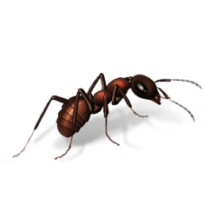  5 x 10⁻⁶ kg
  A human hair is about 4.5 x 10⁻⁵m in diameter |  |   Water intake – average man =  3.5 x 10⁻⁵ kg/sec
  Acceleration at the Equator due to the rotation of the Earth is 3.4 x 10⁻⁴m/s² |  |   Population density of rabbits in Nevada is  1 x 10⁻⁵ per m²
  Mass of an electron at rest = 9.1 x 10⁻³¹kg |  |   Kinetic energy of a falling raindrop = 4 x 10⁻³ J
Lowest temperature achieved in a laboratory =    5 x 10⁻⁴K |  | Power of a bumble bee in flight =    2 x 10⁻² J/s
  Velocity of continental drift = 1 x 10⁻⁹ m/s |  |   The mass of the smallest known virus is 9.5 x 10⁻²¹
Write these as ordinary numbers and then in standard form:

10m in km

2mg in g

5.8mm in km

11ml in litres

Number | Number in standard form
0.008 | 8 x 10⁻³
0.07 | 7 x 10⁻²
0.55 | 5.5 x 10⁻¹
0.000052
0.048
0.0086
0.00086
0.000086
0.0000000001
0.000455

