L.Q. How do I recognise graphs of varying functions? | Date: | 18.6
L.Q. How do I recognise graphs of varying functions? | Name:

Sketch the graph $y=2x+3$ |  | Sketch the graph $y=-x-1$
Sketch the graph $y=x^{2}-2$ |  | Sketch the graph $y={2-x}^{2}$

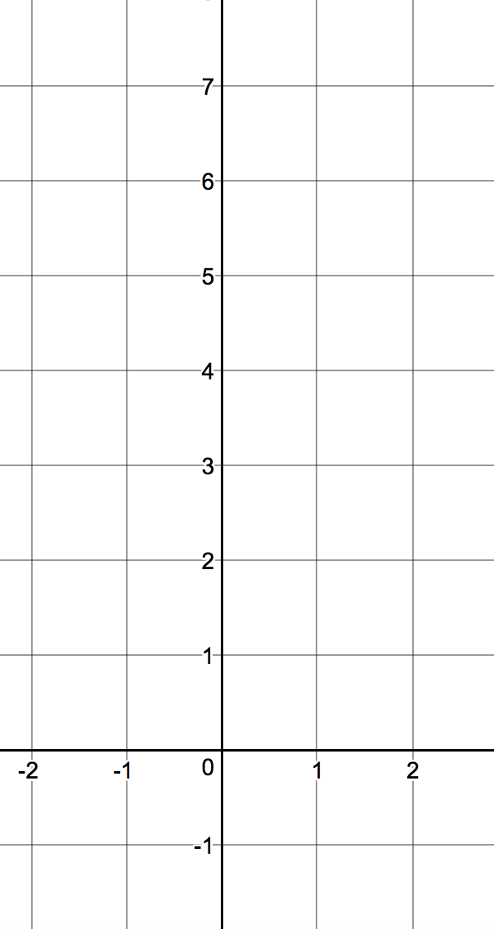
Draw the graph of $y=x^{3}-2x+3$

$$x$$ | -2 | -1 | 0 | 1 | 2
$$x^{3}$$
$$-2x$$
$$+3$$
$$y$$

Shape:

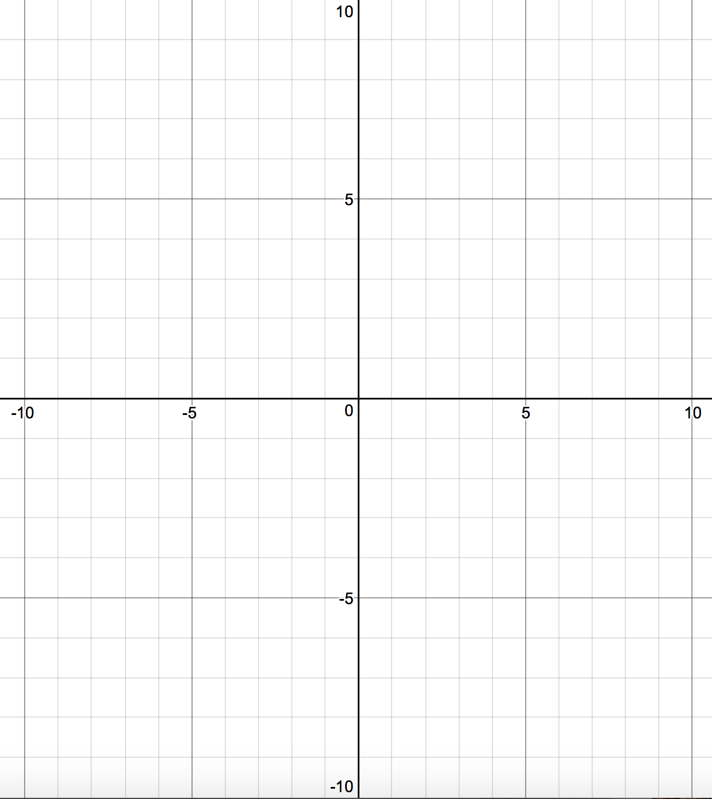
Draw the graph of $y=\frac{4}{x}$

$$x$$ | -8 | -5 | -1 | 0 | 0.5 | 1 | 4 | 10
$$y$$

Shape:

