Graphs Mini Quiz | Date: | 18.5b
Graphs Mini Quiz | Name:
1) Match the correct equation to each graph:

$y=2x-2$ $y=\frac{1}{x}$ $y=x^{2}$ $y=2-2x$ $y=2-x^{2}$ $y=x^{3}$

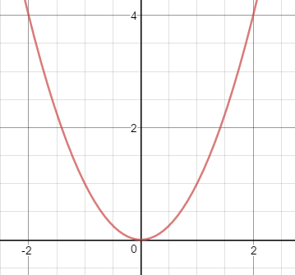 | 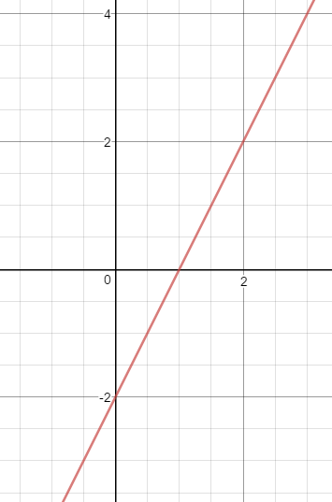 | 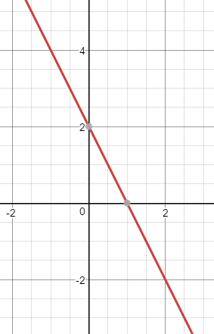
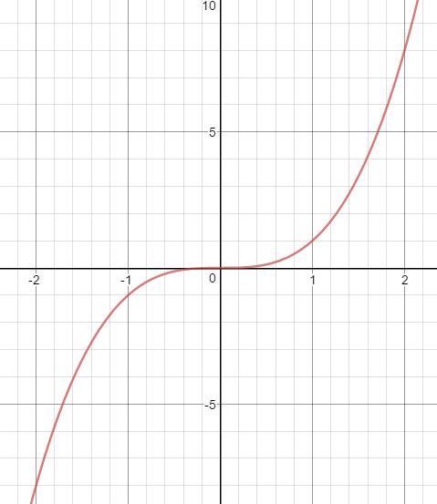 | 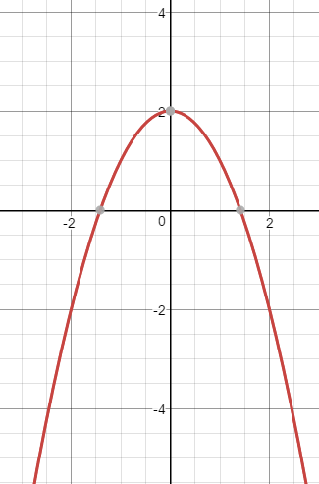 | 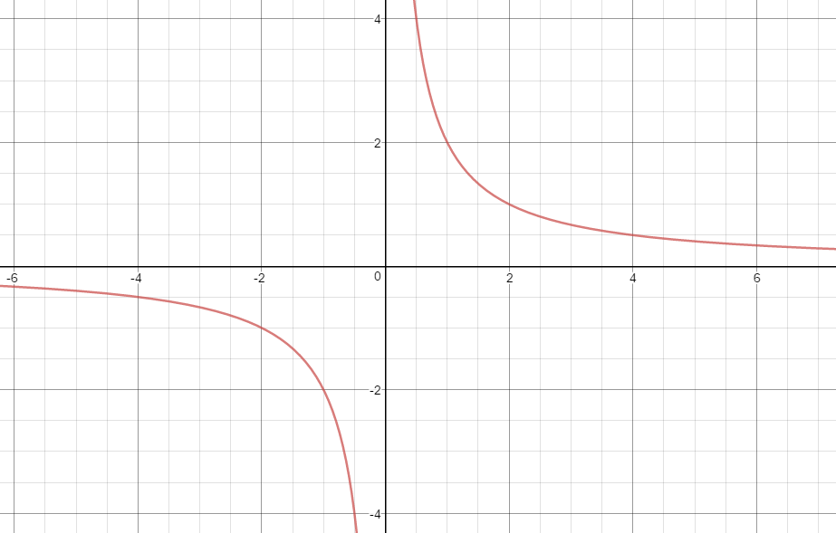
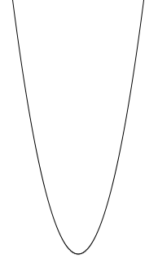
6
x
y
–1
–3
–2
0
1
2
–2
–4
4
2
8

2 Here is the graph of y = x² + 2x – 1 for values of x from –3 to 2.
a) From the graph write down the coordinates of the following
The y-intercept | ( |  | , |  | )
The turning point | ( |  | , |  | )
b) Find the two roots to the graph:

$x=_____________$ and _________________

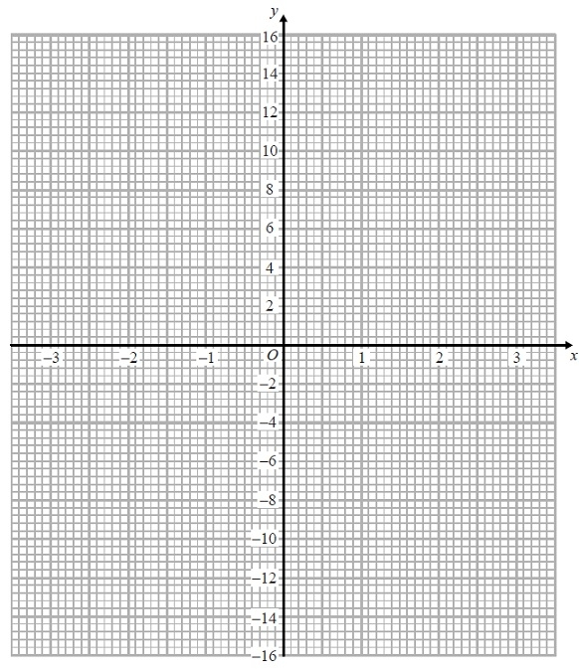
3 (a) Complete the table of values for y = x³ − 4x
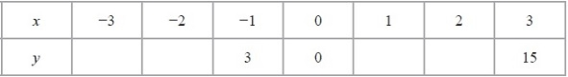

(b) On the grid, draw the graph of y = x³ − 4x from
x = −3 to x = 3

4 (a) Complete this table of values for y = x² + 3x – 1 for values of x from –4 to 2

x | –4 | –3 | –2 | –1 | 0 | 1 | 2
y | 3 | –1 |  | –3 |  |  | 9
4 (b) On the grid draw the graph of y = x² + 3x – 1 for values of x from –4 to 2
6
x
y
–1
–3
–2
0
1
2
–2
–4
4
2
8
–4

4(c) Use the graph to estimate the value of y when x = –0.5

_______________________________
4(d) Use the graph to estimate the solutions (roots) to x² + 3x – 1 = 0

_______________________________

