L.Q. How do I choose between Pythagoras or Trigonometry? | Date:
L.Q. How do I choose between Pythagoras or Trigonometry? | Name:
19.8
For any right angled triangle:

NO
YES
NO
YES

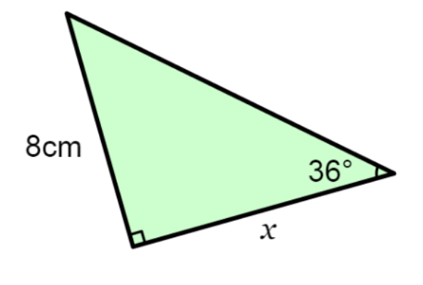

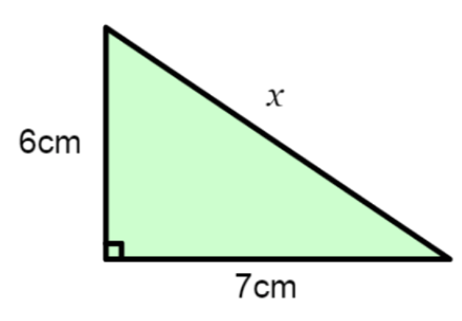

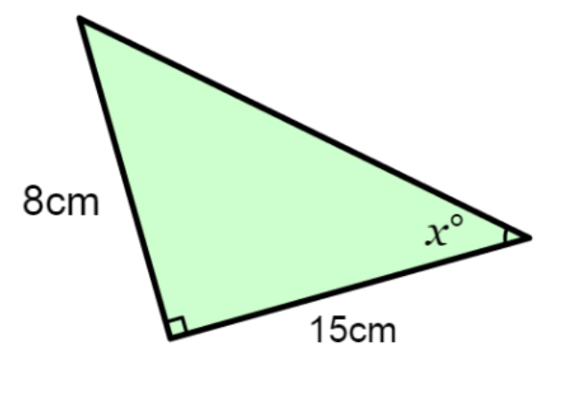

Put the triangle in the correct method needed, then solve.

Missing side using Pythagoras | Missing side using Trig | Missing angle using Trig

Challenge: find the perimeter of these triangles using whichever method is necessary.

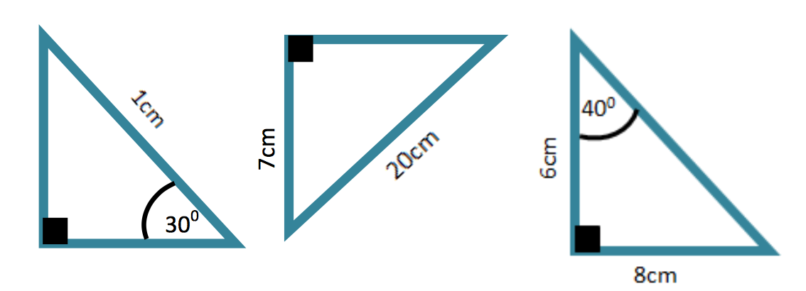
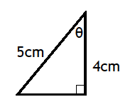 | 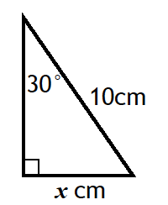 | 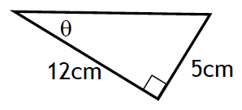
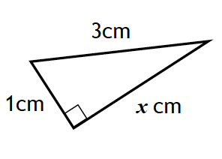 | 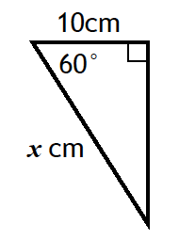 | 