L.Q. How do I represent size and direction using vector notation? | Date: | 19.9
 | Name:

VECTORS

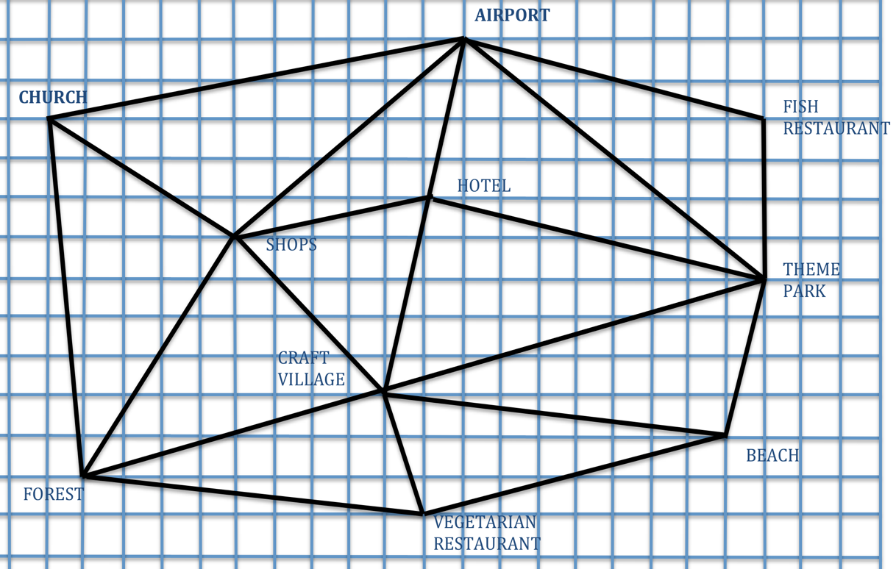

A Write the vectors for these journeys:

Airport to hotel: Hotel to shops: Shops to craft village:
Hotel to Theme Park: Theme Park to hotel:
Church to forest: Forest to Vegetarian Restaurant:
Vegetarian Restaurant to beach: Beach to craft Village:

B Write a list of places you visit, starting at the Hotel each time:

- $\left(\begin{aligned}1 \\ 4\end{aligned}\right)$ $\left(\begin{aligned}8 \\ -2\end{aligned}\right)$ $\left(\begin{aligned}0 \\ -4\end{aligned}\right)$ $\left(\begin{aligned}-10 \\ -3\end{aligned}\right)$ $\left(\begin{aligned}1 \\ 5\end{aligned}\right)$
- $\left(\begin{aligned}-5 \\ -1\end{aligned}\right)$ $\left(\begin{aligned}4 \\ -4\end{aligned}\right)$ $\left(\begin{aligned}-8 \\ -2\end{aligned}\right)$ $\left(\begin{aligned}9 \\ -1\end{aligned}\right)$ $\left(\begin{aligned}8 \\ 2\end{aligned}\right)$
- $\left(\begin{aligned}9 \\ -2\end{aligned}\right)$ $\left(\begin{aligned}-1 \\ -4\end{aligned}\right)$ $\left(\begin{aligned}-9 \\ 1\end{aligned}\right)$ $\left(\begin{aligned}-4 \\ 4\end{aligned}\right)$ $\left(\begin{aligned}-5 \\ 3\end{aligned}\right)$

Vector Notation

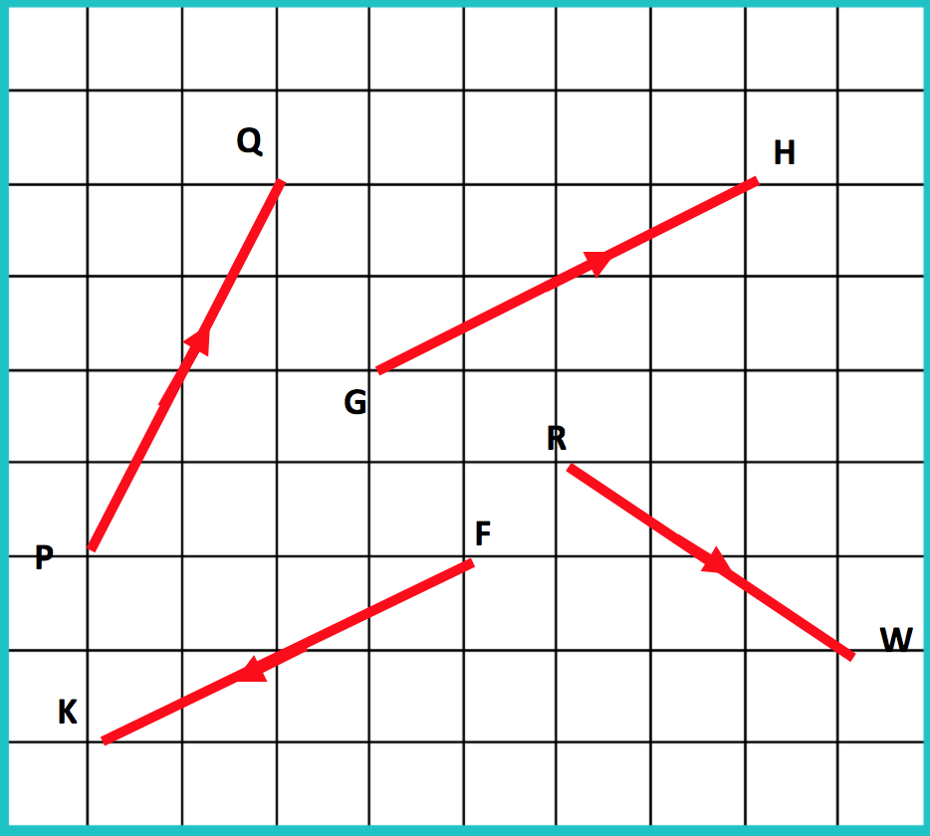

On the grid below draw the vectors:

$\vec{AB}=\left(\begin{aligned}2 \\ -5\end{aligned}\right) \vec{BC}=\left(\begin{aligned}4 \\ 0\end{aligned}\right) \vec{CD}=\left(\begin{aligned}1 \\ 2\end{aligned}\right)$ $\vec{DE}=\left(\begin{aligned}2 \\ -1\end{aligned}\right)$ $\vec{EF}=\left(\begin{aligned}-2 \\ -2\end{aligned}\right)$ $\vec{FG}=\left(\begin{aligned}0 \\ 3\end{aligned}\right)$ $\vec{GH}=\left(\begin{aligned}3 \\ 0\end{aligned}\right)$
$\vec{HI}=\left(\begin{aligned}2 \\ -4\end{aligned}\right) \vec{IJ}=\left(\begin{aligned}1 \\ 3\end{aligned}\right) \vec{JK}=\left(\begin{aligned}3 \\ -2\end{aligned}\right)$ $\vec{KL}=\left(\begin{aligned}1 \\ 3\end{aligned}\right)$ $\vec{LM}=\left(\begin{aligned}-3 \\ 0\end{aligned}\right) \vec{MN}= \left(\begin{aligned}0 \\ -4\end{aligned}\right) \vec{NO}\left(\begin{aligned}3 \\ -1\end{aligned}\right)$

A
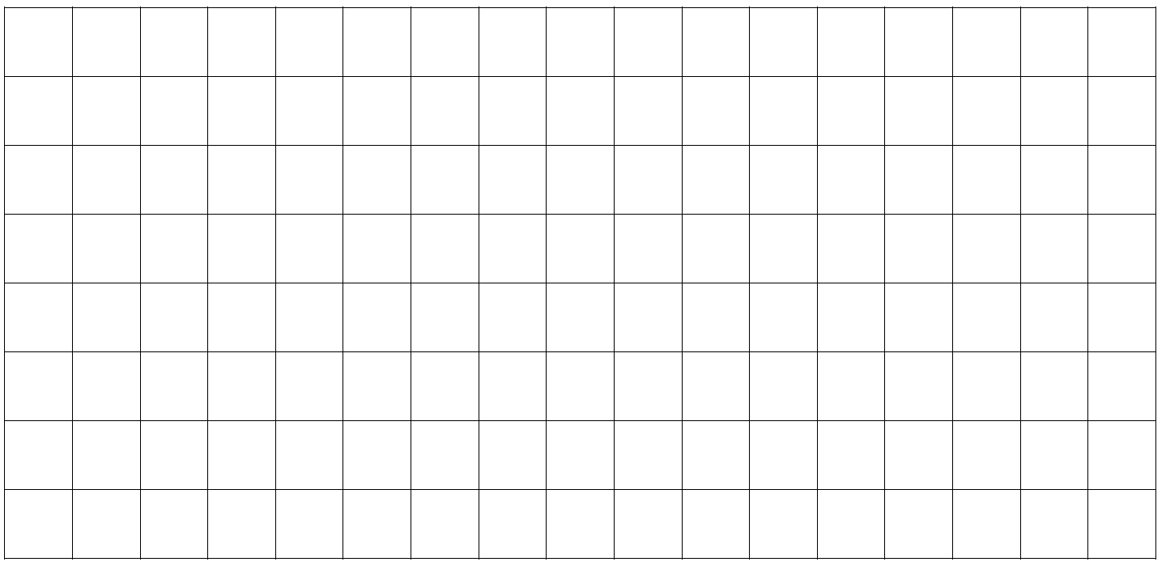

Write down these vectors:

$\vec{BD}=\left(\begin{aligned} \\ \end{aligned}\right)$ $\vec{CE}=\left(\begin{aligned} \\ \end{aligned}\right)$ $GI=\left(\begin{aligned} \\ \end{aligned}\right)$ $\vec{LN}=\left(\begin{aligned} \\ \end{aligned}\right)$ What do you notice about these vectors?

$\vec{BA}=\left(\begin{aligned} \\ \end{aligned}\right)$ $\vec{CB}=\left(\begin{aligned} \\ \end{aligned}\right)$ $\vec{DC}=\left(\begin{aligned} \\ \end{aligned}\right)$ $\vec{FE}=\left(\begin{aligned} \\ \end{aligned}\right)$ What do you notice about these vectors?

