A: Reflect shape S in the line y = -1. | 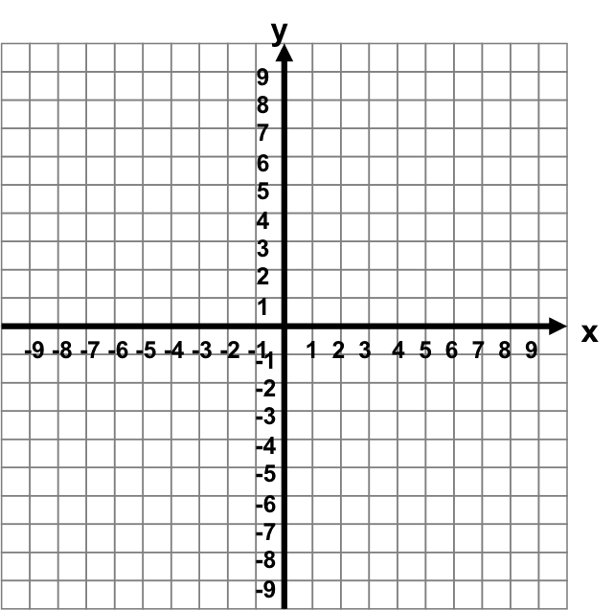  S | C: Translate shape S by the vector  $\left(\begin{aligned}-6 \\ -8\end{aligned}\right)$
B: Rotate shape S 90º anticlockwise about the origin.
A: Reflect shape S in the line y = -1. | S | C: Translate shape S by the vector  $\left(\begin{aligned}-6 \\ -8\end{aligned}\right)$
B: Rotate shape S 90º anticlockwise about the origin.

Translate shape S by the vector $\left(\begin{aligned}-6 \\ -8\end{aligned}\right)$ |  | Reflect shape S in the line y = -1.
 |  | Rotate shape S 90º anticlockwise about the origin.
Translate shape S by the vector $\left(\begin{aligned}-6 \\ -8\end{aligned}\right)$ |  | Reflect shape S in the line y = -1.
 |  | Rotate shape S 90º anticlockwise about the origin.

