$$9x-8=3x+4$$
$$9x-8=3x+4$$

1. ___________________________
to get $x's$ on one side only
2.__________________________
to get $x's$ by themselves
3.___________________________
to find the value of $x$
1. ___________________________
to get $x's$ on one side only
2.__________________________
to get $x's$ by themselves
3.___________________________
to find the value of $x$

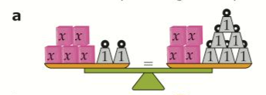  Equation: $5x+2=4x+6$  Subtract  Unknowns:  =  Inverse 1:  Solution: = | 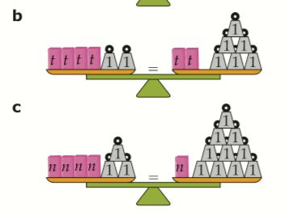  Equation: $4t+2=2t+6$  Subtract  Unknowns:  =  Inverse 1:  =  Inverse 2:  Solution: =
Equation: $n+3=n+10$  Subtract  Unknowns:  =  Inverse 1:  =  Inverse 2:  Solution: = |  | d  $$3n+6=n+14$$  Subtract  Unknowns:  =  Inverse 1:  =  Inverse 2:  Solution: =
Equation: $5x+2=4x+6$  Subtract  Unknowns:  =  Inverse 1:  Solution: = | Equation: $4t+2=2t+6$  Subtract  Unknowns:  =  Inverse 1:  =  Inverse 2:  Solution: =
Equation: $4n+3=n+10$  Subtract  Unknowns:  =  Inverse 1:  =  Inverse 2:  Solution: = |  | d  $$3n+6=n+14$$  Subtract  Unknowns:  =  Inverse 1:  =  Inverse 2:  Solution: =

