
BBQ 14.1 FOUNDATION CALCULATOR ALLOWED

1) | What is the perimeter of the rectangle: | 2) | What is the missing probability?  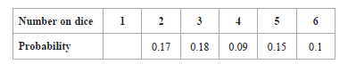
3) | Probability of blue is $\frac{2}{3}.$  Probability of yellow is $\frac{1}{3}.$  What is the probability of blue and yellow? | 4) | Label sides and write calculation to find the missing angle  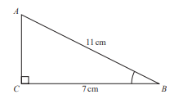
5) | Sketch the construction to find the line that is equidistant between A and B;    A . . B
BBQ 14.1 FOUNDATION CALCULATOR ALLOWED

1) | What is the perimeter of the rectangle: | 2) | What is the missing probability?
3) | Probability of blue is $\frac{2}{3}.$  Probability of yellow is $\frac{1}{3}.$  What is the probability of blue and yellow? | 4) | Label sides and write calculation to find the missing angle
5) | Sketch the construction to find the line that is equidistant between A and B;  A . . B

