
Example 1 | Example 2
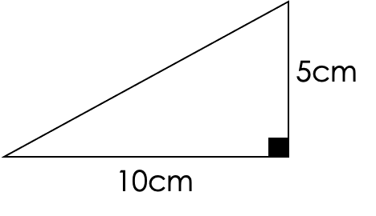  S:  S:  A:  SR: | 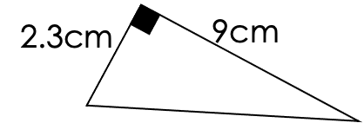  S:  S:  A:  SR:


G
Calculate the longest edge:  7cm  5cm  S:  S:  A:  SR: | 6m  4m  S:  S:  A:  SR: | 5m  9m  S:  S:  A:  SR:
A  11cm  3cm | 12m  20m | 14mm  10mm
R  3.8cm  2.1cm | 2.5m  6.5mm | 9.5m  7.2m
Calculate the length of the diagonal of the rectangle:  P  45cm  34cm | A square has sides of length 10cm.  Find the lengths of its diagonal. | Calculate the side of the triangle:  12cm  8cmm

