4  4 (a)  4 (b) | The chart below shows the UK Retail Price Index from 1986 to 2020.  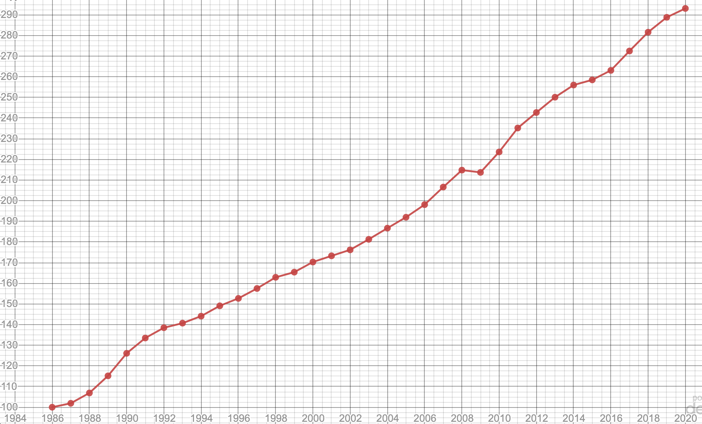  A jar of coffee cost £2 in 1986.  Estimate its cost in 2004?  [2 marks]  A small tank of petrol cost £28 in 2010.  Estimate how much would it have cost in 1995?  [3 marks]
  5
7  7 (a) | Use Sweet Factory from the Preliminary Material  Spherical sweets with a radius of 1mm are packaged in cylindrical tubes.  The cylinders have a height of 10cm and diameter of 4cm.  The factory buys 1m by 1m square cardboard sheets to make the tubes.  Estimate how many sweets can be packaged from 1 of these cardboard sheets.  Give your answer to the nearest 10 sweets.  State any assumptions you make.  You must show your working.  [9 marks]

